
CS673 Software Engineering
Team 1 - Bariatric-Pathway
Software Design Document

Team Member | Role(s) | Signature | Date
Fatimah Hassan | Security Lead and Configuration Co-Lead | Fatimah Hassan | 5/23/2026
Shaima Nimeri | Team Lead  Design and Implementation Lead  Requirement lead | Shaima Nimeri | 5/24/2026
Kai Fernandes | Team Co-Lead  Configuration Co-Lead | K. Fernandes | 5/24/2026
Jianing Li | Requirement Co-Lead | Jianing Li | 5/25/2026
Kolya Gavlishin | QA Lead Design and Implementation Co-LEad | Kolya Gavlishin | 5/25/26

Revision history
Version | Author | Date | Change
1.0 | Fatimah, Shaima, Kolya, Jianing, Kai | 05/24 | Initial document creation
2.0 | Kolya | 06/06 | Updated database description with new diagram  Updated the coordinator dashboard description and added a diagram
2.1 | Fatimah | 06/06 | Updated the Architectural style, the framework and external services, the Gap 1 and Gap 2 to be closed. Added new rows to Security Decisions Log, added AI Microservice security , and Security Posture Summary table.
2.2 | Kai | 06/07 | Updated the class diagram and included UI visuals in our UI section
2.9 | Shaima | 06/07 | Iteration 2 updated the status of REST APIs implemented in iteration 2 and added 2 extra APIs
3.0 | Jianing | 06/08 | Added 4 design patterns used during iteration 2
3.1 | Kolya | 06/15 | Updated 4.2 page inventory with example screenshots  Updated 4.6 - Coordinator Dashboard  Added 4.7 - Director Dashboard Description
3.8 | Shaima | 6/16 | Added section 8 design patterns  Sequence Diagrams  State Diagrams  Application Architecture and Layer breakdown  Deployment

● Introduction
● Software Architecture
● Class Diagram
● UI Design (if applicable)
● Database Design (if applicable)
● Security Design
● Business Logic and/or Key Algorithms
● Design Patterns
● Rest APIs
● Any Additional Topics you would like to include.
Deployment
● AI usage Log
● References
● Glossary

Introduction
BariatricPath is a web-based patient portal designed to streamline the bariatric surgery clearance process. The system serves three user roles — patients, coordinators, and program directors — each with their own dashboard and permissions. The core problem it solves is the lack of clarity patients experience while navigating the pre-surgery evaluation pathway; the portal gives them real-time visibility into their status and checklist progress without needing to contact their coordinator directly.
The system is built as a three-tier React/Node.js/PostgreSQL application, using Firebase Authentication for identity management, Prisma as the ORM, and Docker Compose for local development.
Design Goals
- Security — Patient data is sensitive, so the system uses Firebase Auth (scrypt-hashed passwords, signed JWTs), server-side token verification on every request, role-based access control, and an append-only audit log. The STRIDE threat model was applied to the login flow.
- Usability — The UI is intentionally simple and clinical: Google sign-in, clear error messages via toast notifications, and role-based routing that lands each user directly on the correct dashboard. The goal is to reduce friction for patients who may not be technically savvy.
- Maintainability — A closed-layered backend (Routes → Middleware → Services → Prisma) keeps concerns separated and testable, which is important for a five-person student team working in short iterations.

Software Architecture

2.1 Architectural Style
BariatricPath is implemented as a four-tier system. What was a planned AI microservice in Iteration 2 is now fully built, tested, containerized, and deployed.
• Client Tier (React SPA + Vite): Login/Register/Forgot Password, Patient Portal with AI Chat Widget, Coordinator Dashboard, Program Director Dashboard.
• API Tier (Node.js + Express): REST endpoints, verifyAuth + RBAC middleware, append-only audit logging, gateway/proxy to the AI service.
• Data Tier (PostgreSQL + Prisma): User and Patient tables, AuditLog table, Notifications table, Prisma migrations.
• AI Service (FastAPI + LangChain + ChromaDB): Role-based RAG chatbot, runs on the internal Docker network only (no public port), called via Express only, conversation memory of the last 7 exchanges.
Security note: the AI service is never exposed publicly. Every AI request is gated by Express, which first verifies the Firebase ID token - RBAC is enforced before any request reaches the AI service.
Why a microservice for AI, but not for everything else? The choice reflects a deliberate trade-off. At our scale (five members, seven weeks), splitting every domain into its own service would multiply operational complexity without proportional value. We chose microservices only where the boundary is naturally sharp: the AI service is written in Python (because LangChain's Python ecosystem is more mature than its JavaScript equivalent) and has a fundamentally different deployment profile (stateless, GPU-friendly, third-party API calls). The Express backend remains a single deployable unit because every part of it shares the same runtime, database, and authentication model.

2.2 System Architecture Diagram
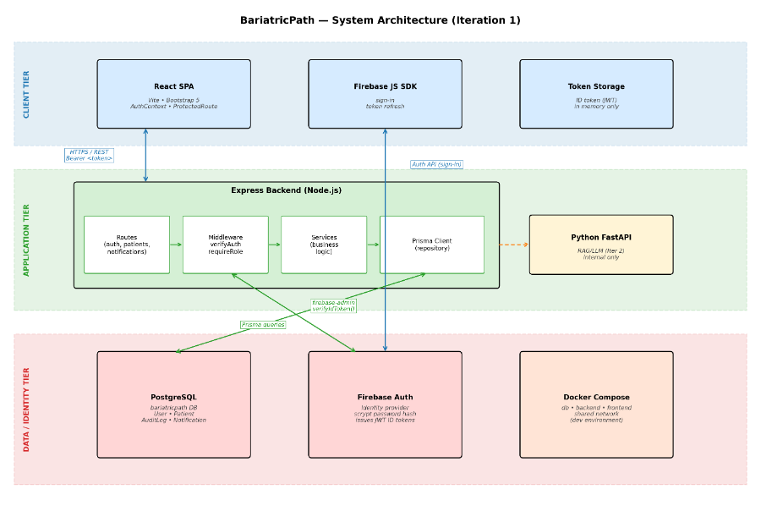
Figure 1. BariatricPath system architecture — three-tier layout showing the client tier (React SPA, Firebase JS SDK, in-memory token storage), the application tier (Express backend with internal layers: Routes – Middleware – Services – Prisma Client; FastAPI to be added in Iteration 2), and the data/identity tier (PostgreSQL, Firebase Auth, Docker Compose).

Application Architecture and Layer Breakdown
BariatricPath is composed of four layers: a React frontend, an Express backend API, a FastAPI AI service, and a PostgreSQL database, with Firebase providing authentication as an external service. The diagram below shows how these layers communicate with each other.
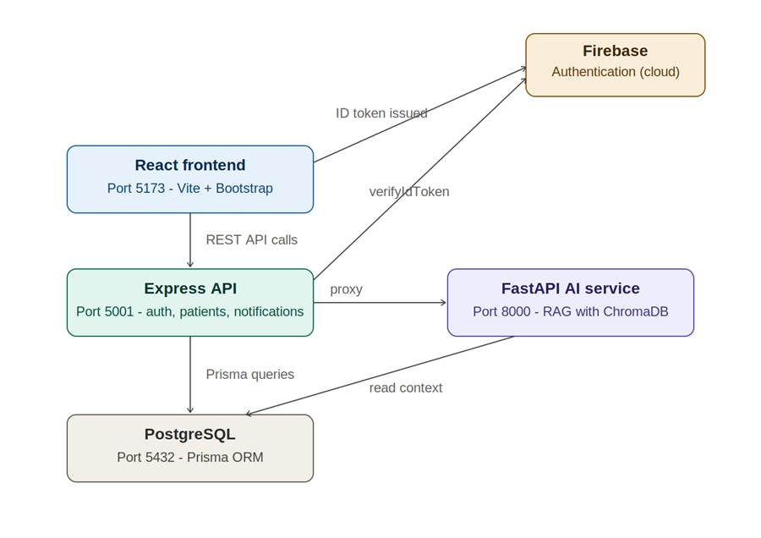
Figure 15. Application architecture

Frontend - React (port 5173)
The frontend is a single-page application built with React and Vite, styled with Bootstrap. It is responsible for rendering the patient portal, coordinator dashboard, and program director dashboard, and for managing client-side authentication state through the AuthContext. All data requests are made to the Express API using the apiRequest facade, which attaches the Firebase ID token to each request.

Backend - Express API (port 5001)
The backend is a Node.js Express application that exposes REST endpoints under /api/auth, /api/patients, /api/notifications, and /api/ai. It verifies Firebase tokens on protected routes, enforces role-based access control, performs all database operations through Prisma, writes audit log entries for data changes, and proxies AI chat requests to the FastAPI service.

AI Service - FastAPI (port 8000)
The AI service is a separate Python FastAPI application that implements the retrieval-augmented generation pipeline. It receives enriched requests from the Express backend, retrieves relevant context from a ChromaDB vector store, and calls a language model to generate responses to patient questions about their care plan.

Database - PostgreSQL (port 5432)
PostgreSQL stores all persistent application data across the User, Patient, AuditLog, and Notification tables described in the database architecture section. All access to the database goes through the Prisma ORM, which is configured as a singleton shared across the Express application.

Sequence Diagrams
This section illustrates the end-to-end message flow for the application's most significant workflows: patient registration, login and role-based routing, a coordinator updating a patient's clinical status, and the AI chat assistant.

Patient Registration
When a new patient registers, the browser sends the registration form to Express, which creates the corresponding Firebase account and then uses a single Prisma transaction to create the User, Patient, and AuditLog records together. If any part of the transaction fails, all three records are rolled back, so the database is never left with a partial registration.
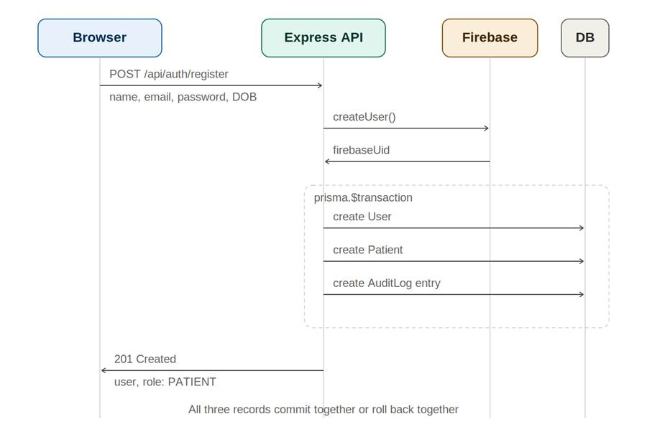
Figure 2. Patient registration sequence

Login and Role-Based Routing
When a user logs in, the browser authenticates directly with Firebase to obtain an ID token. The browser then sends this token to Express, which verifies it with Firebase and looks up the user's role in PostgreSQL. The role is returned to the browser, where the RoleRouter component sends the user to the patient portal, coordinator dashboard, or director dashboard depending on their role.
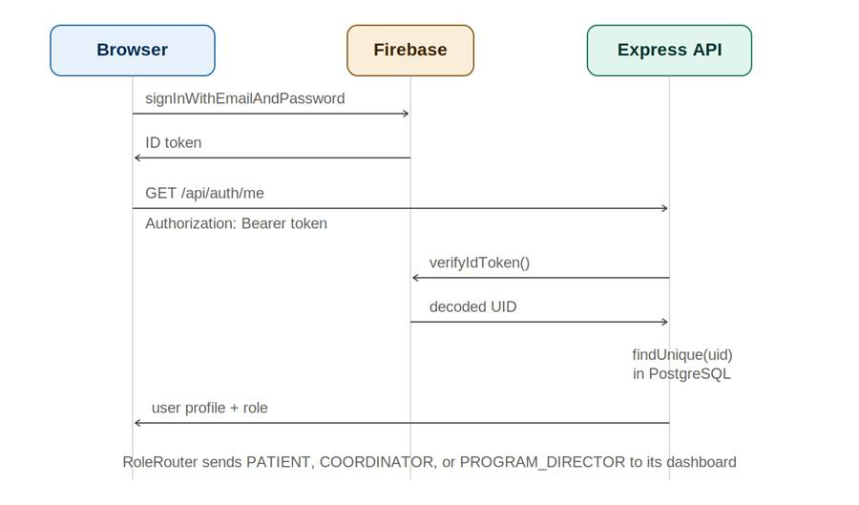
Figure 3. Login and role-based routing sequence

Coordinator Updates Clinical Status
When a coordinator changes a checklist item, such as marking labs as complete, the browser sends a PATCH request to Express with the column name and new value. Express validates that the column name is one of the allowed clinical fields, looks up the patient's current value, applies the update, writes an AuditLog entry recording the old and new values, creates a Notification for the patient, recalculates the patient's progress, and returns the updated patient record.
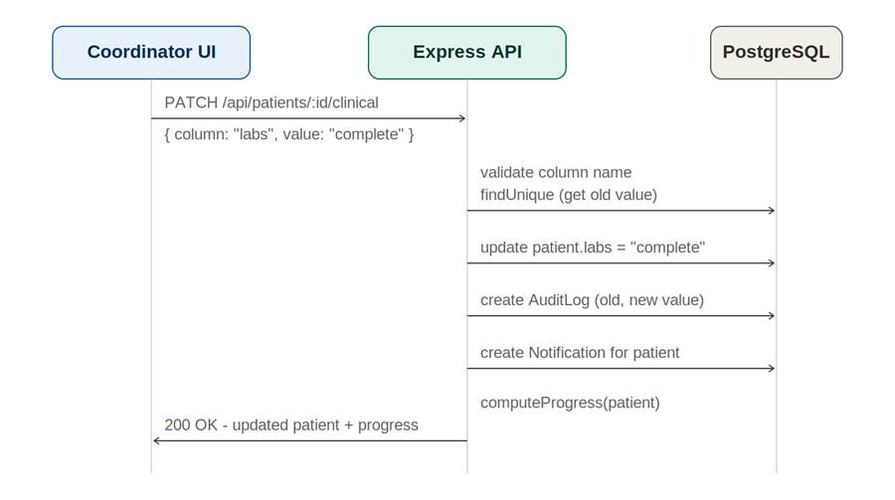
Figure 4. Coordinator updates clinical status sequence

AI Chat (Retrieval-Augmented Generation)
When a patient asks the AI assistant a question, the browser sends the question to Express. Express verifies the patient's authentication token and enriches the request with relevant patient context before forwarding it to the FastAPI AI service. The AI service retrieves relevant document chunks from ChromaDB, builds a prompt that includes this retrieved context, and calls the language model to generate an answer. The answer is returned back through Express to the browser.
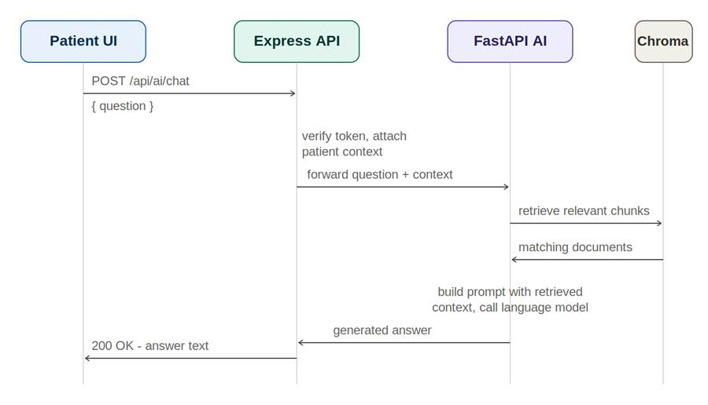
Figure 5. AI chat sequence using retrieval-augmented generation

State Transition Diagrams
This section presents state transition diagrams for the key entities and workflows in BariatricPath: user authentication, patient onboarding, the clinical checklist item lifecycle, insurance status, patient progress toward surgery clearance, notifications, and an overall summary of how the three user roles move through the system.

User Authentication States
A user begins logged out. Calling signIn() moves the application into a verifying state while the Firebase token is checked. On success the user becomes logged in and a role check routes them to the patient portal, coordinator dashboard, or director dashboard based on their role. On failure the user sees an auth failed state with an error message and can retry. From any authenticated dashboard, signOut() returns the user to the logged out state.
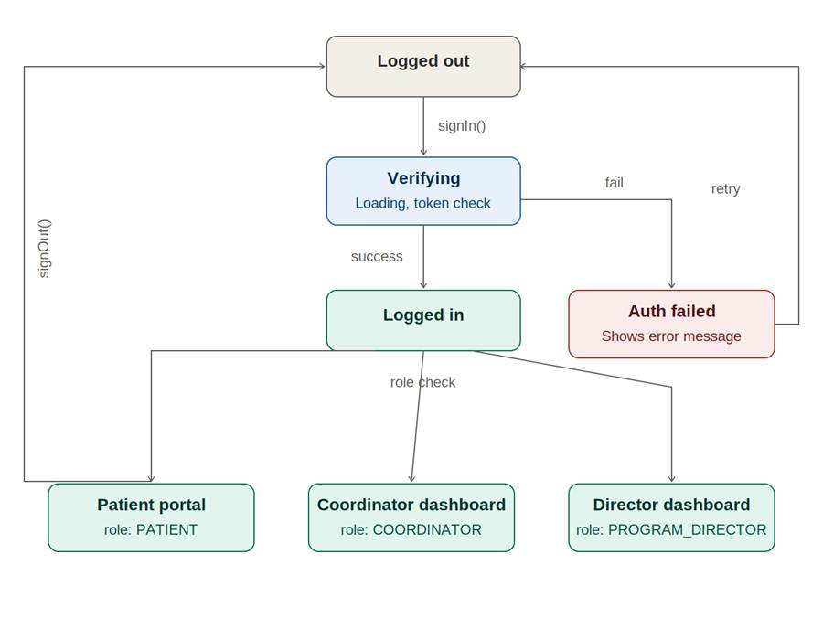
Figure 8. User authentication states

Patient Onboarding States
A new user begins registration, which triggers a BMI calculation from their height and weight. If the BMI is below 27, the patient is moved to an ineligible state and redirected. If the BMI is 27 or above, the patient moves to specialist selection. Calling selectSpecialist() moves the patient to a profile incomplete state where their checklist is open for review. Once the patient calls submit(), the profile moves to a submitted state and the thank-you page is shown.
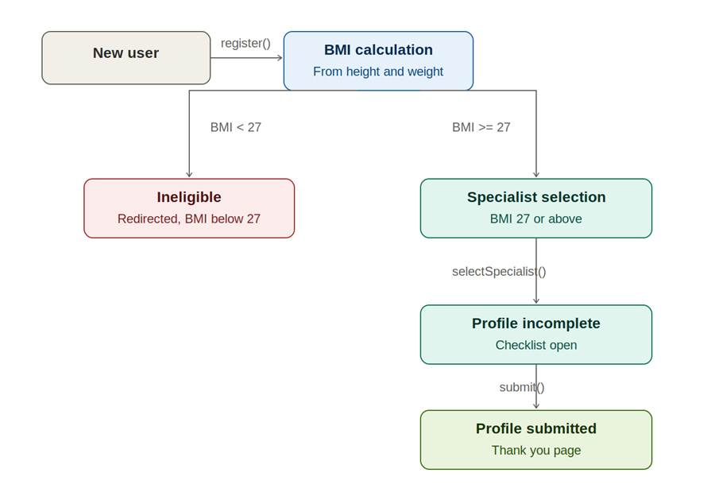
Figure 9. Patient onboarding states

Clinical Checklist Item States
Each clinical checklist field starts as not required, the default for most fields. Once a specialist type is selected, any field required for that specialist becomes not complete. As the coordinator updates the field, it can move through ordered and in progress before reaching complete, at which point it counts toward the patient's progress bar. The coordinator can revert an item from in progress back to not complete if needed.
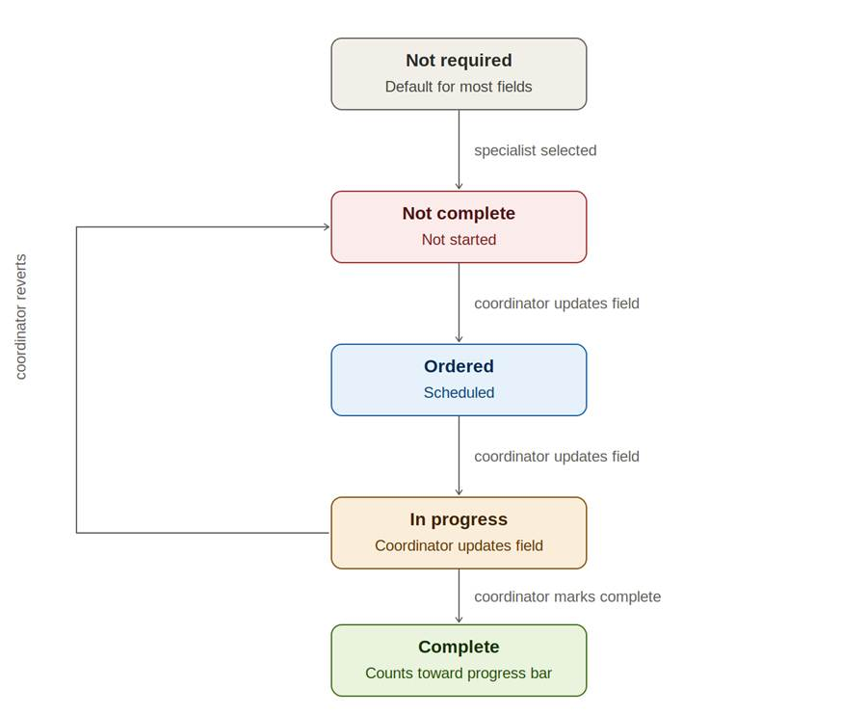
Figure 10. Clinical checklist item states

Insurance Status States
A patient's insurance status starts as not clear at registration. When the coordinator reviews the patient, the status moves to either in review or self pay, depending on the patient's situation. From in review, the coordinator's decision results in either clear, if approved, or a return to not clear, if rejected and still pending further information.
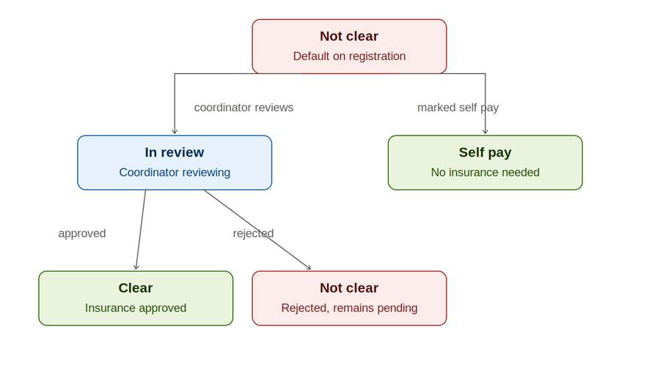
Figure 11. Insurance status states

Patient Progress and Surgery Clearance States
Before a specialist is selected, a patient has no specialist assigned and their progress is reported as zero out of zero. Once a specialist is selected, the patient enters an in progress state where their progress is tracked as completed items out of the total required for their specialist type. When all required items reach complete, the patient enters the surgery cleared state, and the patient portal displays a green clearance banner.
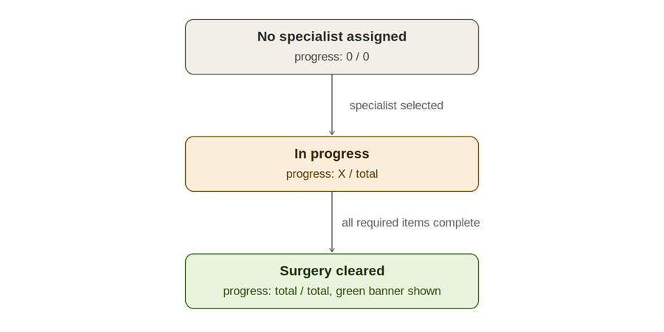
Figure 12. Patient progress and surgery clearance states

Notification States
A notification is created with isRead set to false whenever a patient submits their profile or a coordinator updates the patient's status. When the coordinator opens the notification card and views the notification, it transitions to read, with isRead set to true.
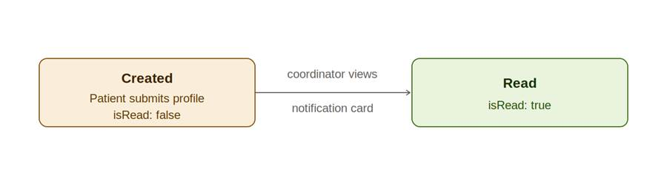
Figure 13. Notification states

Overall System State Summary

At a high level, every user begins unauthenticated. Logging in or registering moves the user into the authenticated state, where their experience depends on their role. A patient progresses from their BMI result to specialist selection to checklist submission. A coordinator views the patient list and updates patient records until they are cleared. A program director views pipeline metrics and the overall patient list. From any authenticated role, logging out returns the user to the unauthenticated state.
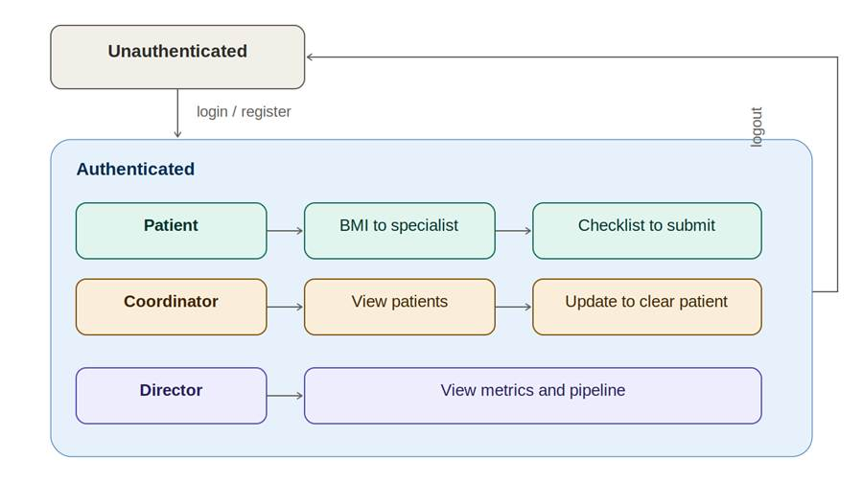
Figure 14. Overall system state summary

2.3 Component Responsibilities

Component | Responsibility | Tier
React SPA | Renders all user interface, handles client-side routing, manages authentication state via AuthContext, gates routes via ProtectedRoute. | Client
Firebase JS SDK | Performs sign-in (email/password and Google), refreshes the ID token automatically before expiry. | Client
Token storage | Holds the Firebase ID token in JavaScript memory (React context). Not persisted to localStorage or cookies. | Client
Express Routes | Parses HTTP requests, validates inputs with express-validator, and routes to the correct controller logic. | Application
Auth middleware (verifyAuth) | Verifies the Firebase ID token on every protected request using firebase-admin.verifyIdToken(). | Application
Role middleware (requireRole) | Enforces role-based access control (PATIENT, COORDINATOR, PROGRAM_DIRECTOR). | Application
Services | Encapsulate business logic such as patient status transitions and audit log writes. Stateless. (Being formalized in Iteration 1.) | Application
Prisma Client | Repository layer — issues type-safe SQL queries to PostgreSQL based on the schema in server/prisma/schema.prisma. | Application
PostgreSQL | Persistent storage for User, Patient, AuditLog, and Notification entities. A dedicated database user (bariatric_user) is used in development. | Data
Firebase Auth | External identity provider. Hashes passwords (scrypt), issues ID tokens (signed JWTs with ~1-hour expiry), and supports federated Google sign-in. | Identity
Docker Compose | Orchestrates db, backend, and frontend containers on a shared internal network for the development environment. | Infrastructure

2.4 Frameworks and External Services

Layer | Framework / Service | Rationale
Frontend | React 18 + Vite + Bootstrap 5 | React is the de-facto SPA framework; Vite gives instant hot reload; Bootstrap provides a consistent design system without bespoke CSS.
Backend | Node.js 20 + Express 4 | Lightweight, well-understood, and the team is comfortable with JavaScript end-to-end.
ORM | Prisma 5 | Type-safe queries; auto-generates a typed client from the schema; migrations are first-class.
Database | PostgreSQL 15 | Industry-standard relational database with strong transactional guarantees; well-suited to the relational data model.
Identity | Firebase Authentication | Mature, free for our usage tier, supports email/password and Google federation, handles secure password hashing (scrypt), and issues JWT ID tokens we can verify server-side.
AI (Iter 2) | Python FastAPI + LangChain + ChromaDB | Shipped in Iter 2. Written in Python because LangChain's Python ecosystem is more mature than JavaScript's. Runs in its own container on the shared Docker internal network; reachable only from the Express backend. ChromaDB is used as the vector store for RAG document retrieval. Code lives in ai-service/.
Containers | Docker + Docker Compose | Consistent development environment for the whole team; trivial path to deployment in Iteration 2/3.
Testing | Jest, Supertest, React Testing Library | Standard, widely-supported, well-documented for the chosen stack.

2.5 Inter-Component Communication
• Client ↔ Backend: HTTPS REST. All authenticated requests carry an Authorization: Bearer <token> header containing the Firebase ID token.
• Backend ↔ Firebase Auth: the backend uses firebase-admin to verify ID tokens server-side. It does not issue or manage tokens — Firebase does that.
• Backend ↔ PostgreSQL: Prisma Client over a standard PostgreSQL connection on the internal Docker network.
• Backend ↔ AI Service (built Iter 2 ):): internal HTTP only. The Express backend forwards authenticated AI chatbot requests to the FastAPI service at http://ai-service:8000 (Docker internal DNS). The FastAPI container is [bariatricpath-db
] not exposed via host port mapping, so external clients cannot reach it directly. The Express backend authenticates the user (via verifyAuth middleware) before proxying any request – the FastAPI service trusts the backend's identity assertion and does not implement its own authentication.

2.6 AI Microservice Design - Role-Based RAG
The AI Chat Assistant uses Retrieval-Augmented Generation (RAG): the AI answers from BariatricPath's own knowledge base, not just general training data. The pipeline (implemented in ai-service/rag.py) runs in four steps:
Step | Description
1. Retrieve | The question is converted to a vector embedding (OpenAI) and ChromaDB is searched for the top RETRIEVAL_TOP_K = 3 most similar documents, filtered by role metadata (patient / coordinator / program_director).
2. Augment | A single prompt is assembled from: the role-specific system prompt, the retrieved documents, the patient's live data (insurance, visit type, progress), and the last MEMORY_WINDOW_SIZE = 7 conversation exchanges.
3. Generate | The augmented prompt is sent to GPT-4.1-mini via LangChain's llm.ainvoke(). This is the only step that calls OpenAI.
4. Remember | The new question/answer pair is appended to an in-memory dict keyed by session_key (role + patient_id), then trimmed back to the last 7 exchanges - a sliding window.

Role-based knowledge bases and prompt behavior:
Role | Prompt Style | Response Length | Knowledge Source
PATIENT | Warm, encouraging | 2-3 sentences | bariatric_program_faq.csv
COORDINATOR | Professional, direct | 3 sentences or steps | coordinator_guide.csv
PROGRAM_DIRECTOR | Strategic, data-focused | Max 5 bullet points | director_guide.csv

Documented limitation: conversation memory is held in an in-process Python dictionary for this iteration's scope - it is NOT persisted to the database and is lost on service restart. The production path forward is to move this to Redis or a Prisma-backed table, keyed by session_key.
Sequence Diagram - AI Chat Request (end-to-end with security)
This sequence shows the full flow from a user's chat question through authentication, role-based access control, and the AI microservice boundary:
• 1. User asks a question in the chat widget (available on all three portals).
• 2. React frontend sends POST /api/ai/chat with the Firebase ID token and the user's role.
• 3-4. Express runs verifyAuth, which calls Firebase's verifyIdToken(token) and receives back the decoded UID and role.
• 5-6. Express fetches the patient's real context (insurance, specialist, progress) from Prisma/PostgreSQL.
• 7. Express forwards the question, role, and context to the AI service over the internal Docker network only (http://ai-service:8000) - this hostname does not resolve outside the Docker network.
• 8. FastAPI runs the RAG pipeline: ChromaDB retrieval (top 3) + GPT-4.1-mini generation.
• 9-10. The JSON answer is returned through Express to the React frontend.
• 11. The answer is rendered in the chat bubble.
Key design point: authentication and RBAC (steps 3-4) happen BEFORE any AI call - an unauthenticated or wrongly-roled request never reaches the AI service.
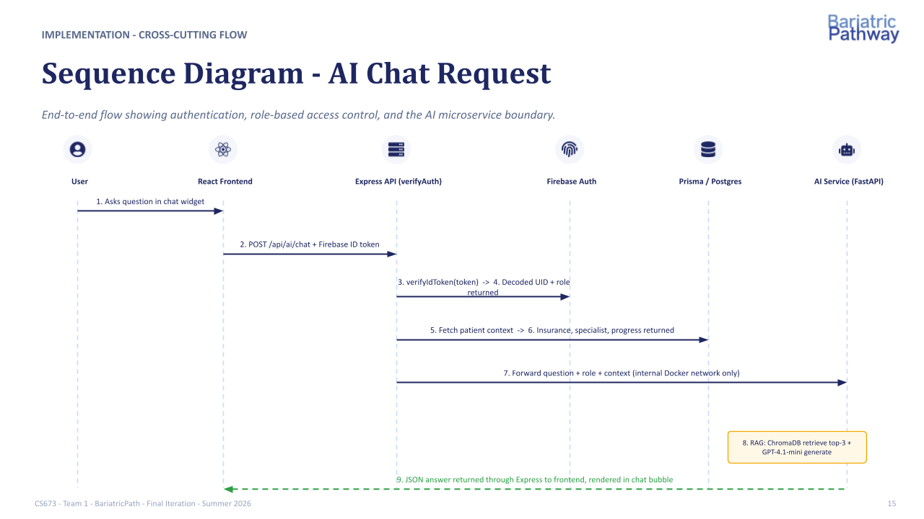

2.7 Deployment View
Development: every team member runs the system locally via Docker Compose, which brings up three containers: db, backend, and frontend. Each developer also runs their own local Firebase project for testing, while the shared Firebase project is used for integration testing.
Production (planned for Iteration 2/3): the system will be deployed to Digital Ocean, with the same three-container layout, plus the FastAPI AI container, behind a managed load balancer with TLS termination.

Class Diagram

User - The User class is the central identity entity in BariatricPath. It represents every person who has an account in the system, regardless of role. Each User stores a firebaseUid which is the unique identifier issued by Firebase Authentication and acts as the bridge between the external identity provider and the local database record. The role field determines which dashboard the user is routed to upon login and which API endpoints they are permitted to call. A User record is created transactionally alongside a Firebase account during registration, meaning both must succeed or both are rolled back. The User class has a composition relationship with Patient, AuditLog, and Notification, meaning those records cannot exist without an associated User.
Patient - The Patient class represents the clinical record for a bariatric surgery candidate. It is the central data entity in the system and acts as the single source of truth for a patient's evaluation progress. Each Patient is linked to exactly one User through the userId foreign key. The class stores the patient's physical measurements (bmi, height, weight) used for eligibility screening, as well as a collection of clearance fields (surgeonClearance, psychClearance, dietitianClearance) that track specialist sign-offs. The surgeryClearedFlag is set to true when all required clearances are complete, triggering the "Surgery Cleared" banner on the patient portal. The status and insuranceStatus fields capture the patient's current position in the bariatric evaluation pathway. The Patient class has a composition relationship with both AuditLog and Notification, as those records are always created in the context of a specific patient record.
AuditLog - The AuditLog class provides an immutable, append-only record of every change made to a patient's data. Each entry captures the userId of the actor who made the change, the patientId of the affected record, the column that was modified, and both the oldValue and newValue so that the full history of any field can be reconstructed. The timestamp is always server-generated to prevent client-side manipulation. By application convention the audit log is never updated or deleted through the application surface — only created. This satisfies the accountability pillar of the system's IAAA security model and provides a complete audit trail for coordinators and program directors. AuditLog has no direct relationship to Notification; both are independently triggered by PatientService when a field update occurs.
Notification - The Notification class stores user-facing alerts that are generated whenever a coordinator updates a patient's checklist. Each record holds the userId of the recipient (always the patient), the patientId of the record that changed, a human-readable message describing the update, and a read flag that tracks whether the patient has seen the notification. Unlike AuditLog, which is a compliance record, Notification is purely a UX concern — it exists to keep patients informed without requiring them to call their coordinator. Notifications are created by NotificationService and are independent of AuditLog entries, even though both are produced by the same update event.
Role (enumeration) - Role is a Prisma enum that defines the three permitted user types in the system: PATIENT, COORDINATOR, and PROGRAM_DIRECTOR. It is referenced as a field type on User and as a parameter type in the requireRole middleware. Defining roles as an enum rather than a free-text string provides type safety at the ORM level — it is impossible to assign an invalid role through the application. Adding a new role would require a database migration, which is an acceptable trade-off since roles change rarely.
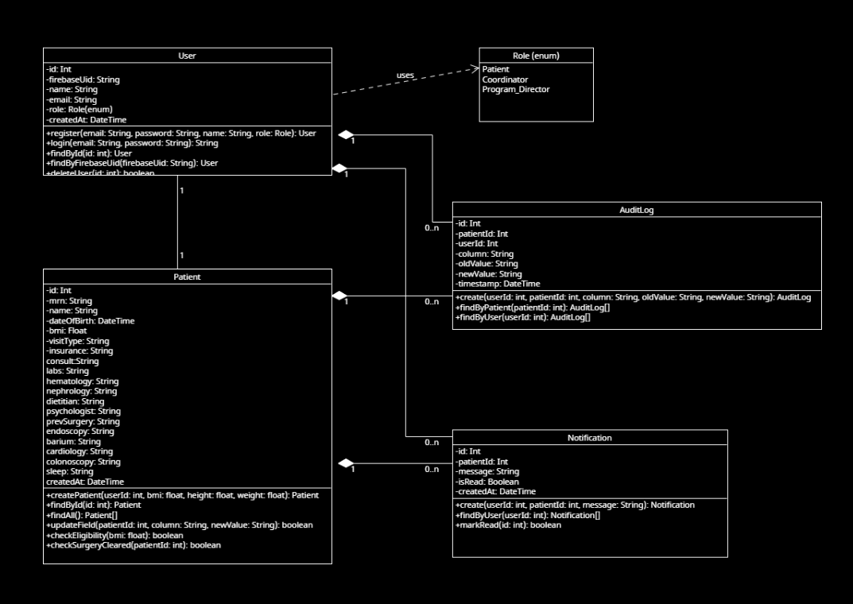

Package: server/middleware
This package contains three middleware files that form the security and logging pipeline for every API request. All three run before any route handler executes.
verifyAuth (verifyAuth.js) - verifyAuth is the authentication gate for every protected API endpoint. It runs first in the middleware chain and is responsible for proving that the caller is who they claim to be. It extracts the Firebase ID token from the Authorization: Bearer header, calls firebase-admin.auth().verifyIdToken() to validate the JWT signature, expiry, audience, and issuer against Google's public keys, and then looks up the matching local User record by firebaseUid. On success it attaches the resolved User object to the request for downstream handlers. On any failure — missing header, malformed token, expired token, or no matching local user — it returns 401 Unauthorized immediately and the request goes no further. It has a «uses» dependency on AuthService (routes/auth.js) to perform the local user lookup. Every protected route in the system runs verifyAuth before any other middleware.

requireRole (auth.js) - requireRole enforces role-based access control at the route level. It is a factory function — called with an array of permitted Role values, it returns an Express middleware function that checks the authenticated user's role against that list. If the role does not match it immediately returns 403 Forbidden. It depends on verifyAuth having already run and attached the user to the request; it never authenticates independently. It has a «uses» dependency on PatientService since patient routes are the primary endpoints it protects. On the client side ProtectedRoute performs an equivalent check for UX purposes, but requireRole on the server is the true security boundary. Note: this class lives in middleware/auth.js — distinct from routes/auth.js which handles registration and login.

auditLogger (auditLogger.js) - auditLogger is the audit logging middleware responsible for recording every state-changing operation on patient records. It intercepts requests after authentication and authorization have passed and, following a successful response, writes an AuditLog entry capturing the actor's userId, the affected patientId, the column changed, and the oldValue and newValue. It uses a database transaction via writeTransaction() to ensure the audit write and the patient update always succeed or fail together — a partial write where the patient record changes but no audit entry is created is never permitted. It has a «calls» dependency on PatientService to retrieve the before-state of a field prior to the update. This module reflects the Iteration 2 refactor described in the SDD, where inline audit writes in route handlers were centralized into a dedicated middleware.

Package: server/routes

This package contains the three route handler files that implement the application's business logic. Each file maps to a REST resource and exposes the endpoints for that resource.

AuthService (auth.js) - AuthService handles all authentication and user registration logic. Its most critical responsibility is the transactional registration flow: it calls firebase-admin.auth().createUser() to create the Firebase identity record, then creates the matching local User row in PostgreSQL within a Prisma transaction. If the database write fails, rollbackFirebaseUser() is called to delete the Firebase record and restore a consistent state, ensuring a user can never sign in without a local profile. The login() method verifies a Firebase ID token and returns the resolved user's role so the client can route to the correct dashboard. verifyToken() wraps the firebase-admin call and is used by verifyAuth middleware to resolve the local user from a token. Note: this file is routes/auth.js — distinct from middleware/auth.js which contains requireRole.

PatientService (patients.js) - PatientService is the core business logic layer of BariatricPath. It manages all patient record operations and is the most depended-upon class in the system. The updateField() method is the most important — it updates a single column on a patient record and triggers both auditLogger middleware and NotificationService to ensure the change is logged and the patient is alerted. checkEligibility() enforces the BMI threshold rule, blocking patients with a BMI below 27 from completing registration. checkSurgeryCleared() evaluates all clearance fields on a patient record and sets the surgeryClearedFlag when all are true, which triggers the Surgery Cleared banner on the patient portal. getPatients() returns the full patient list used by the coordinator and director dashboards. It holds a dependency on PrismaClient as its repository layer and has «calls» relationships to both auditLogger and NotificationService.

NotificationService (notifications.js) - NotificationService manages patient-facing notifications. When PatientService updates a patient field it calls notify() which creates a new Notification record for the affected patient with a human-readable message describing the change. getUnread() retrieves all unread notifications for a given user and is polled by the patient portal to populate the notification badge. markAllRead() clears the unread state when the patient opens their notification panel. NotificationService operates entirely independently of auditLogger — both are triggered by the same update event in PatientService but neither is aware of the other, keeping their concerns cleanly separated.

Package: client/src

This package contains the two client-side classes responsible for authentication state management and route protection across the React application.

AuthContext (context/) - AuthContext is a React context that holds the global authentication state for the entire client application. It stores the currently signed-in User object and the Firebase ID token in JavaScript memory only — never in localStorage or cookies — to eliminate the risk of XSS token theft. signIn() calls the Firebase JS SDK, receives the ID token, and stores it in the context so every component in the application can access it without prop drilling. signOut() calls firebase.auth().signOut(), clears all stored state, and redirects to /login. Because the token lives only in memory it is lost on a full page reload, requiring the user to sign in again — an accepted trade-off in a clinical context where persistent sessions carry greater risk than the inconvenience of re-authentication.

ProtectedRoute / roleRedirect (utils/) - ProtectedRoute is a React wrapper component that guards every authenticated page. It reads the current user and token from AuthContext — which is why it has an aggregation relationship with AuthContext (it uses it but does not own it) — and checks two conditions before rendering its children: that the user is authenticated, and that the user's role matches the requiredRole prop. If either check fails the user is redirected to /login. The companion utility roleRedirect runs immediately after a successful sign-in and programmatically navigates the user to /patient, /coordinator, or /director based on their role. Together these two utilities ensure users always land on the correct page and can never manually navigate to a page above their permission level on the client side, though requireRole middleware on the server remains the authoritative security boundary.
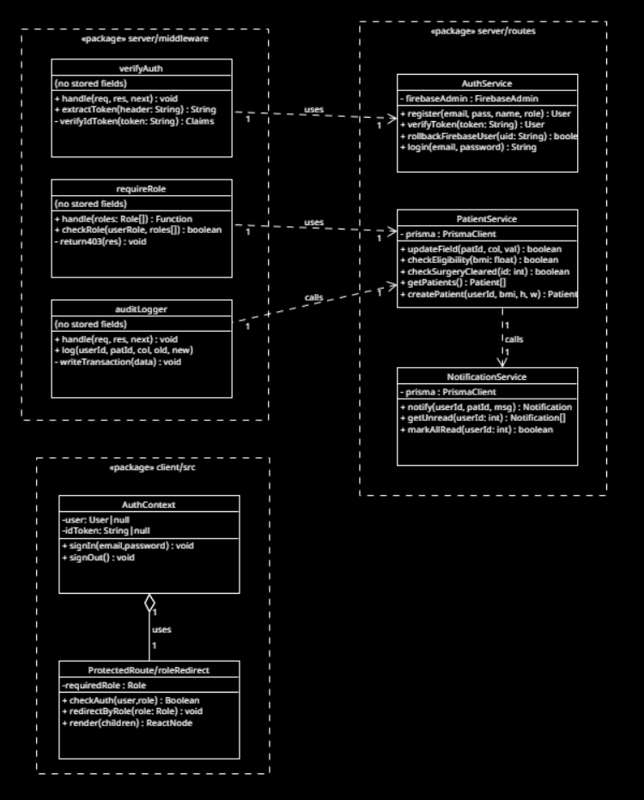

UI Design (if applicable)

4.1 Design Approach
BariatricPath uses Bootstrap 5 as the design system. This decision was deliberate: a small student team building an MVP under tight time pressure benefits from a battle-tested, accessible, responsive component library far more than it benefits from a bespoke design language. The visual identity is intentionally clean and clinical – neutral grays, a single accent color, and high text contrast – to match the professional tone the use case demands.
All pages are built as React functional components. Shared chrome (the top navigation bar with sign-out, the toast notifications container) lives in App.jsx and is present on every authenticated page.

4.2 Page Inventory and diagrams
Page | Path | Audience | Purpose
LoginPage | /login | Public | Email/password and Google sign-in.
RegisterPage | /register | Public | New user account creation.
PatientPortal | /patient | PATIENT | View own pathway status, notifications, and profile.
CoordinatorDashboard | /coordinator | COORDINATOR | List patients in caseload, update workflow fields inline.
PatientDetail | /coordinator/patients/ | COORDINATOR | List and edit an individual patient’s complete clinical checklist
DirectorDashboard | /director | DIRECTOR | Show a view only version of the patient list and summary metrics
Login page: 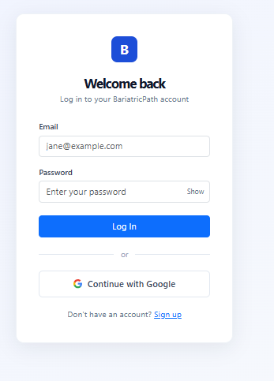
Register page: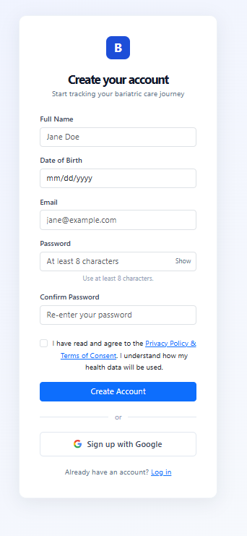
Patient portal: 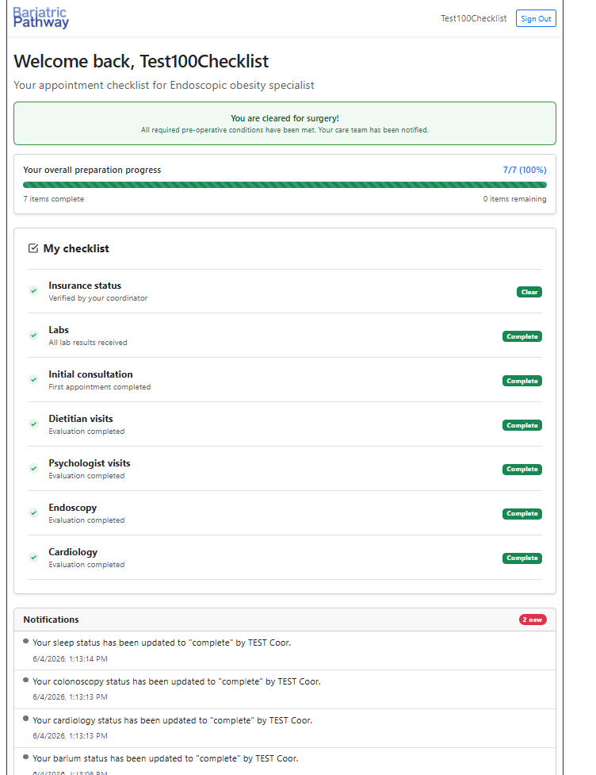
Coordinator dashboard: 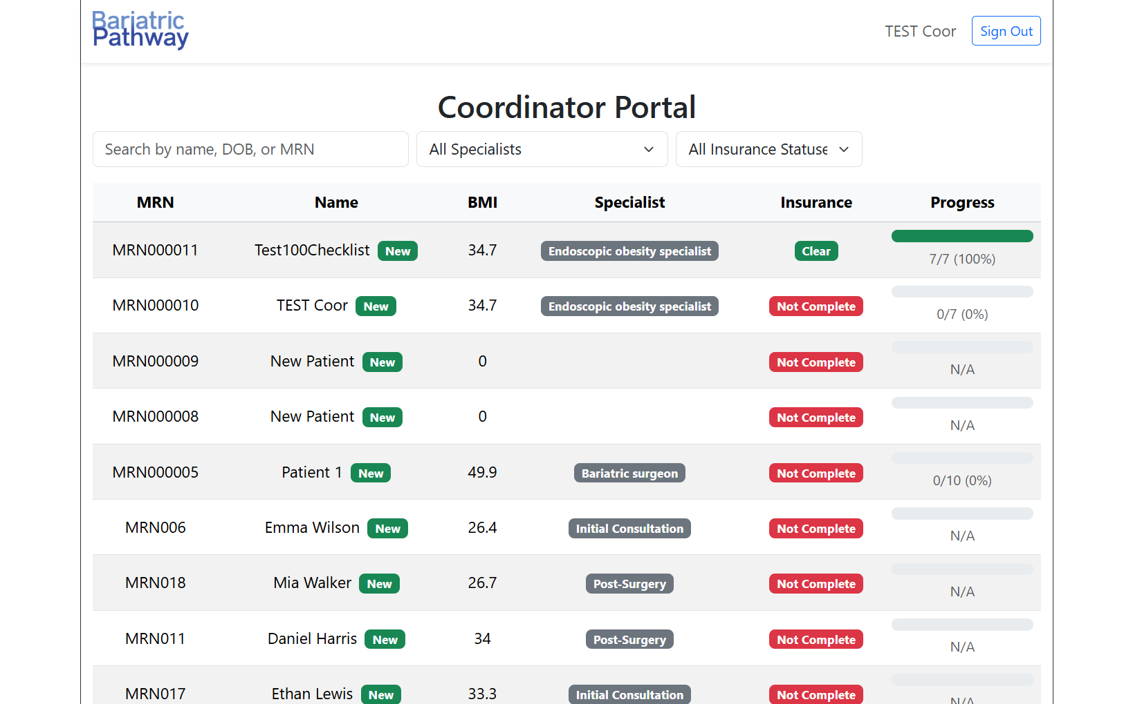
Patient Detail Page:
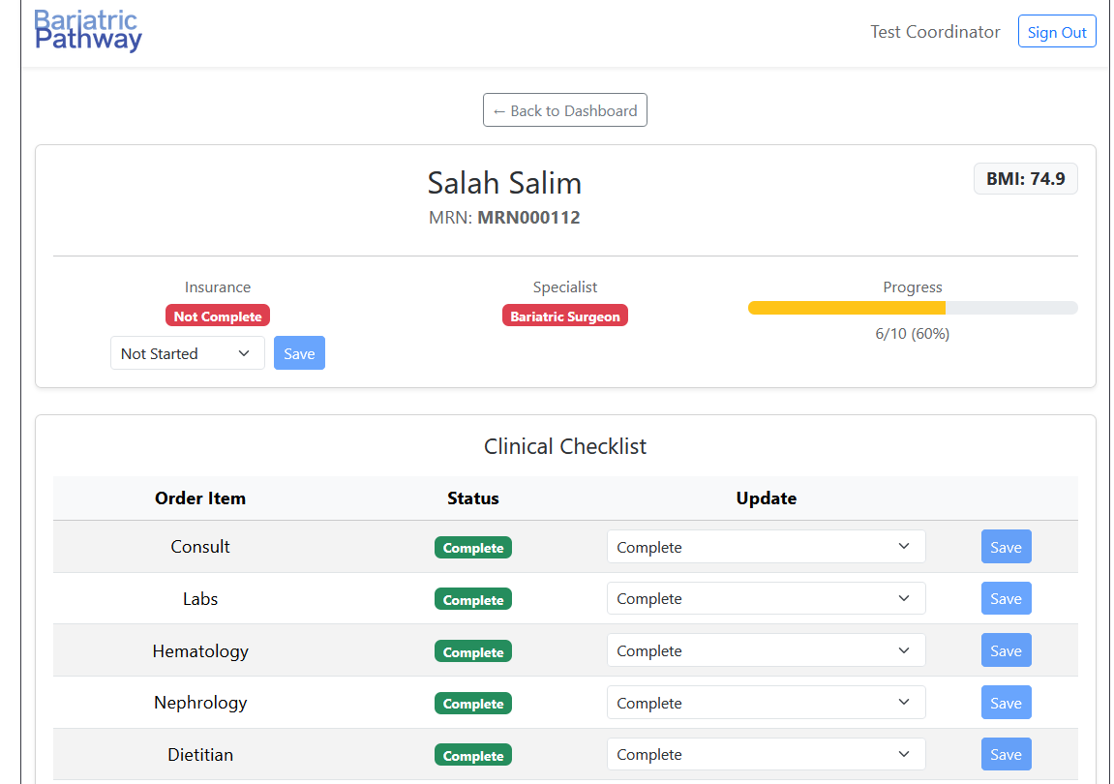

Director Dashboard: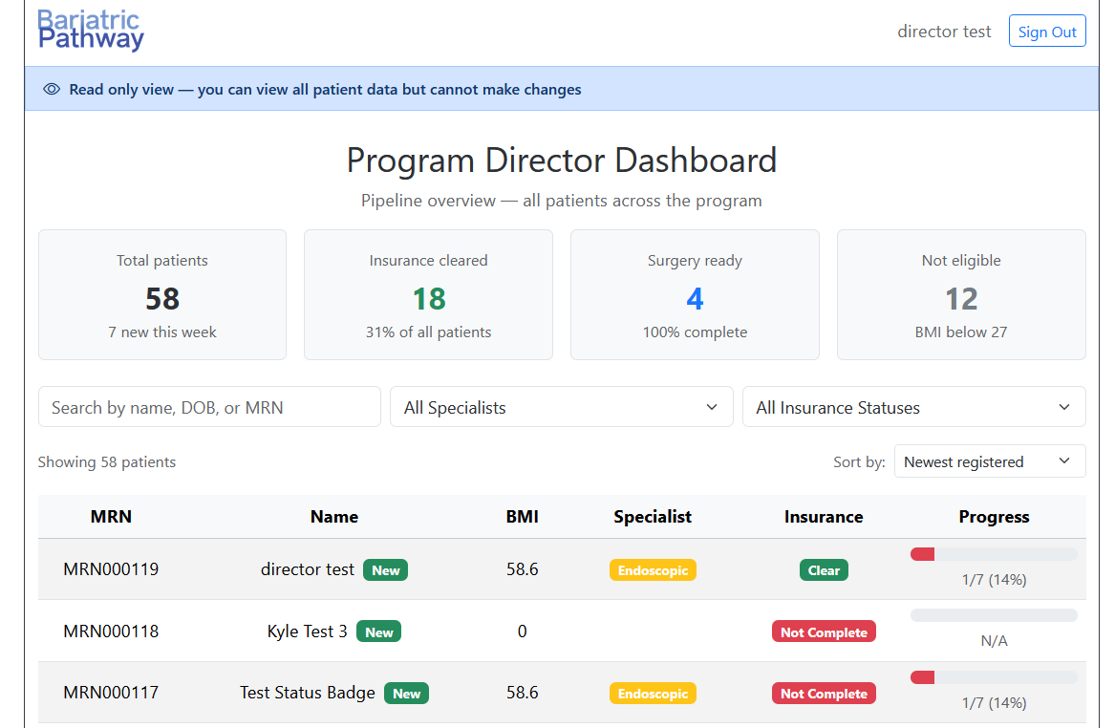

4.3 Authentication UX Flow
• A user lands on /login (or is redirected there by ProtectedRoute).
• They either sign in with email/password or click "Sign in with Google".
• On success, the AuthContext receives the user object and Firebase ID token.
• A small utility (roleRedirect.js) inspects the user's role and routes them to the correct dashboard: /patient, /coordinator, or /director.
• Every protected page is wrapped in <ProtectedRoute requiredRole="...">; the wrapper checks both authentication and authorization before rendering.
• Sign-out clears the AuthContext and calls Firebase signOut(), then redirects to /login.

4.4 Notifications and Feedback
All user feedback (success messages, validation errors, network errors) is delivered via toast notifications using the react-toastify library. The team standardized on toast notifications instead of inline form errors to keep the UI uncluttered and to provide a consistent feedback channel across pages.

4.5 Accessibility Considerations
• All form inputs have associated <label> elements with explicit htmlFor.
• Bootstrap's components ship with reasonable ARIA attributes; we do not override them.
• Color is never the only signal — required fields show an asterisk; errors show both color and a text message.
• Sign-in buttons (including the Google sign-in button) have descriptive text and meet contrast requirements.

4.6 Coordinator Dashboard
The coordinator dashboard currently has two main features: the search bar and the patient table.

The search bar is at the top of the page and supports live search by name, date of birth, or MRN. It is debounced — the search fires 300ms after the user stops typing, so no submit button is needed. Next to the search input are two dropdown menus to filter by specialist type and insurance status. The specialist filter options are: Not Eligible, Obesity Medicine Specialist, Endoscopic Obesity Specialist, and Bariatric Surgeon. While data is loading, a loading indicator is shown. If the API call fails, a red error alert is displayed. If no patients match the active filters, a contextual message is shown ("No patients match your filters." vs. "No patients found." when no filters are applied).

When results are present, a count line ("Showing X patients") appears on the left, and a sort control appears on the right. The sort dropdown offers seven options: Newest registered, Progress: highest first, Progress: lowest first, Name: A to Z, Name: Z to A, BMI: highest first, and BMI: lowest first. The default sort is Newest registered.

Below the search bar is the patient list table, which displays all patients when the coordinator logs in. Each row shows the MRN, name, BMI, specialist type, insurance status, and checklist progress. Rows are clickable — clicking a row navigates to that patient's detail page. Patients created within the last 7 days display a green "New" badge next to their name.

Specialist and insurance values are displayed as colored badges. For specialist type: Not Eligible is gray, Obesity Medicine Specialist is blue, Endoscopic Obesity Specialist is yellow, and Bariatric Surgeon is red. For insurance status: clear is green, not clear is red, self pay is gray, and in review is yellow.

Progress is displayed as a bar accompanied by a completed/total (pct%) label. The color reflects how far along the checklist is: below 40% is red, 40–99% is yellow, and 100% is green. If no checklist items exist for a patient, the bar is hidden and "N/A" is shown instead.

---

Clicking a patient row opens the patient detail page. At the top of the page is a "Back to Dashboard" button that returns the coordinator to the dashboard. While patient data is loading, a centered spinner is shown. If the fetch fails, a red error alert is displayed.

The page is divided into two sections: the patient header card and the clinical checklist.

The patient header card displays the patient's name, MRN, and BMI. Below those fields, three columns show the insurance status, specialist type, and overall checklist progress. The specialist badge and progress bar are read-only. Insurance is editable: a dropdown lets the coordinator select a new status (clear, not clear, self pay, or in review), and a Save button submits the change. The Save button is disabled until the selection differs from the current value. If the save fails, an error message is shown below the dropdown.

The clinical checklist is a table with one row for each of the eleven pre-surgery checklist items: Consult, Labs, Hematology, Nephrology, Dietitian, Psychologist, Endoscopy, Barium Swallow, Cardiology, Colonoscopy, and Sleep Study. Each row shows the item name, its current status as a colored badge, a dropdown to select a new status, and a Save button. The available status options are: not required, not complete, ordered, in progress, and complete. As with insurance, the Save button is disabled until the value changes, shows a spinner while saving, and displays an inline error message if the save fails. Saving any checklist item updates the progress bar in the header in real time.

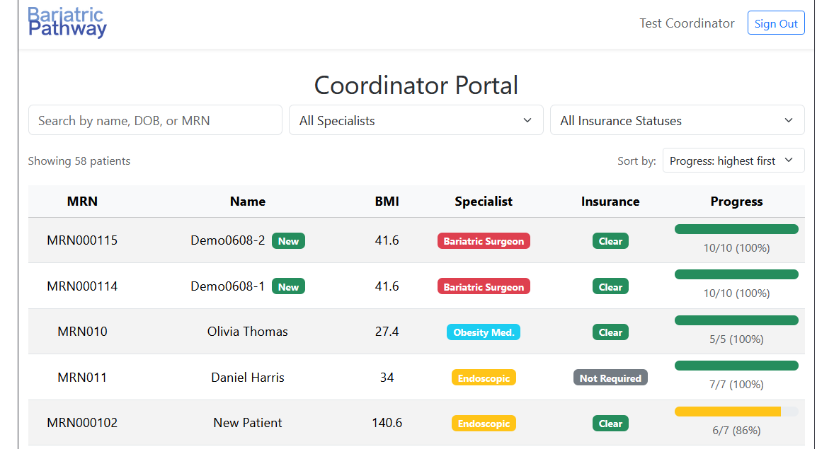

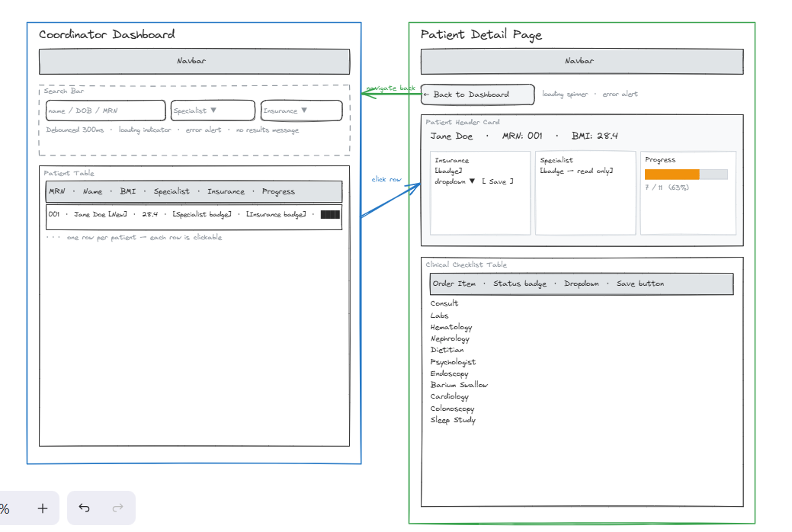

4.7 Director Dashboard

The director dashboard is a read-only view of the entire patient pipeline. It has four main sections: the read-only banner, the patient metrics panel, the patient list, and the AI chat widget.

At the top of the page, directly below the navigation bar, a blue banner reads "Read only view — you can view all patient data but cannot make changes." This banner is always visible and signals that the program director role carries no edit permissions. The page heading below it reads "Program Director Dashboard" with the subtitle "Pipeline overview — all patients across the program."

Below the heading is the patient metrics panel, which shows four summary cards in a responsive grid. The first card shows the total number of patients in the program with a sub-label counting how many were added in the last seven days. The second card shows the number of patients whose insurance is cleared, with a sub-label expressing that count as a percentage of all patients (displayed in green). The third card shows the number of patients who are surgery ready — defined as having a 100% complete checklist — displayed in blue. The fourth card shows the number of patients not eligible, defined as those with a BMI below 27, displayed in gray. While the metrics are loading, "Loading metrics..." is shown in place of the cards. If the fetch fails, "Failed to load metrics." is shown in red.

Below the metrics panel is the patient list, which uses the same search bar and table layout as the coordinator dashboard. The search input supports live search by name, date of birth, or MRN, debounced at 300ms. Next to the search input are dropdown filters for specialist type and insurance status with the same options as the coordinator dashboard. If the API call fails, a red error alert is shown. If no patients match the active filters, a contextual message is displayed.

When results are present, a count line ("Showing X patients") appears on the left, and a sort control appears on the right. The sort dropdown offers seven options: Newest registered, Progress: highest first, Progress: lowest first, Name: A to Z, Name: Z to A, BMI: highest first, and BMI: lowest first. The default sort is Newest registered.

The patient table displays the same columns as the coordinator dashboard: MRN, name, BMI, specialist type, insurance status, and checklist progress. Badge colors and progress bar behavior are identical to the coordinator view. Patients added within the last seven days still display a green "New" badge. However, table rows are not clickable — the cursor remains a default pointer and no navigation to the patient detail page occurs. There are no edit, update, or save controls anywhere on the page.

In the bottom-right corner of the screen is a floating circular button with a chat bubble icon. Clicking it opens the BariatricPath AI Assistant panel. The panel opens with the welcome message "Hi! I can help with program metrics and performance insights." Before the director sends any message, two suggested questions are shown as pill buttons: "What metrics should I track?" and "How do I identify bottlenecks?" Clicking a suggested question sends it immediately. The director can also type a question in the input field and submit it with the Send button or by pressing Enter. User messages appear on the right side of the panel in blue; assistant responses appear on the left in gray. While a response is being generated, a "Thinking..." indicator is shown. If the AI request fails, the assistant replies with "Sorry, I could not process your question right now. Please try again or contact your coordinator." Clicking the floating button again closes the panel.

Database Design (if applicable)

For our database, we decided to use PostgreSQL hosted on Supabase. We use the Prisma Object Relational Mapper to interface with the database in development instead of writing SQL directly.

Our schema has four entities: User, Patient, AuditLog, and Notification. The Role type is defined as a database-level enum with three values: PATIENT, COORDINATOR, and PROGRAM_DIRECTOR. These roles affect the permissions given to each user in the system.

The User model stores a name, email, and role, along with a firebaseUid for Firebase-based authentication and a createdAt timestamp. Each user can be associated with many audit log entries. A user may also be optionally linked to a single Patient record via a one-to-one relation, which allows patients who have a login account to be connected to their clinical record.

The Patient model is the most extensive. It includes an optional userId foreign key that links the patient record to a User account (with a unique constraint ensuring the one-to-one relationship). It also includes attributes for MRN (unique), name, date of birth, BMI (defaulting to 0), and visit type, as well as one attribute for each item on the pre-surgery checklist (insurance, consult, labs, hematology, nephrology, dietitian, psychologist, previous surgery, endoscopy, barium, cardiology, colonoscopy, and sleep study). All checklist fields have schema-level defaults (e.g., "not required", "not complete") so new patients are always in a valid state. Each patient can have many associated audit logs and notifications.

The AuditLog entity is a history table that records every change made to a patient record. Each entry captures which column changed, the old value, the new value, and a timestamp. It references both the Patient and the User who made the change, with both foreign keys being nullable so that log entries are preserved even if a patient or user is deleted.

The Notification entity stores messages to be sent to patients. Each notification records the message content, a boolean isRead flag indicating whether the notification has been read, a createdAt timestamp, and a reference to the patient it belongs to.

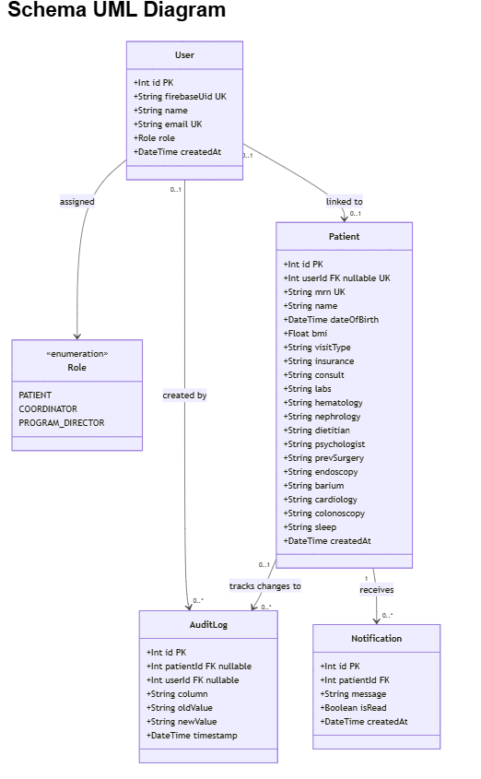

Entity field reference (current schema):
Entity | Fields
User | id (PK), firebaseUid, name, email, role, createdAt
Patient | id (PK), userId (FK), mrn, name, dateOfBirth, bmi, insurance, visitType, progress
ClinicalChecklist | id (PK), patientId (FK), item name, status, updatedAt
Notification | id (PK), userId (FK), message, isRead, createdAt
AuditLog (append-only) | id (PK), userId / patientId, column, oldValue / newValue, timestamp (immutable)

Design notes:
• Firebase handles authentication - no password fields are stored in our database.
• AuditLog is immutable and append-only - supports compliance and forensic review of every status change.
AI conversation memory is NOT persisted to this database - documented limitation (in-memory only, scoped per session).

Security Design

6.1 Security Goals
BariatricPath handles protected health information (PHI). Security was a design requirement from Sprint 1, not an afterthought - every layer of the stack enforces its own controls so that a failure in one layer does not expose the whole system. We follow a defense-in-depth model across five layers:

Layer | Controls
1. Identity & Access | Firebase Authentication (ID tokens, password hashing); verifyAuth middleware on every protected route; Role-Based Access Control (Patient / Coordinator / Director)
2. Application Layer | Input validation on all forms and API payloads; parameterized queries via Prisma (no raw SQL); account-enumeration protection on password reset
3. Data & Privacy | Append-only AuditLog for every status change; no plaintext passwords stored anywhere; mandatory Privacy Policy & Consent before access (BARI-156)
4. Network & Infra | AI service isolated on the internal Docker network only; HTTPS via Nginx reverse proxy in production; secrets managed via environment variables, never committed
5. Continuous Verification | SAST (CodeQL) on every PR and weekly; container/secret scanning (Trivy); DAST (OWASP ZAP) against the running AI service

The security design of BariatricPath is organized around the CIA triad and the IAAA model:
• Confidentiality — patient records and audit logs are visible only to authorized users acting in authorized roles.
• Integrity — the patient record cannot be modified except through the application, and every modification is recorded permanently in the audit log.
• Availability — the system stays responsive under expected demo load (out of scope to harden further in this academic project).
• Identification, Authentication, Authorization, Accountability — every actor has an identity (Firebase UID), proves it (Firebase ID token), is authorized for each action (RBAC + ownership checks), and leaves an audit trail (AuditLog).

6.2 Threat Model — STRIDE Analysis of the Login Flow
The login flow is the highest-value security target in the system. If an attacker can either impersonate a legitimate user or obtain an arbitrary user's session, every downstream control becomes moot. The following table applies the STRIDE threat model to the login flow shown in Figure 3.
STRIDE category | Threat in our context | Mitigation in our design
Spoofing | An attacker tries to impersonate a user by submitting forged credentials or a forged token. | Firebase authenticates with scrypt-hashed passwords; ID tokens are signed JWTs whose signature, expiry, audience, and issuer are verified server-side by firebase-admin on every protected request.
Tampering | An attacker modifies a request mid-flight to escalate privileges or change which patient is being acted on. | All traffic is HTTPS. The bearer token is signed and cannot be modified without invalidating the signature. Inputs are validated by express-validator before any business logic runs.
Repudiation | A user denies having made a change to a patient record. | Every state-changing action writes an AuditLog row with the actor's userId, the patientId, the column, the old and new values, and a server-generated timestamp.
Information Disclosure | An attacker reads patient data they should not see — including through the IDOR pattern where they request a record they do not own. | Two-layer defense: requireRole enforces role-based access at the route level; the in-progress ownership check (Gap 1 below) enforces object-level access by comparing the requesting user's identity to the resource's owner.
Denial of Service | An attacker floods the system with requests or login attempts. | Out of full scope for this iteration. Firebase Authentication rate-limits sign-in attempts per IP and per account. Backend rate-limiting middleware is on the Iteration 2 backlog.
Elevation of Privilege | A legitimate user tries to invoke an endpoint they are not authorized for, e.g., a patient calling a coordinator-only endpoint. | Defense in depth: ProtectedRoute on the client hides the UI, requireRole on the server returns 403 if the role check fails. The client check is for UX only; the server check is authoritative.

6.3 Login Sequence Diagram
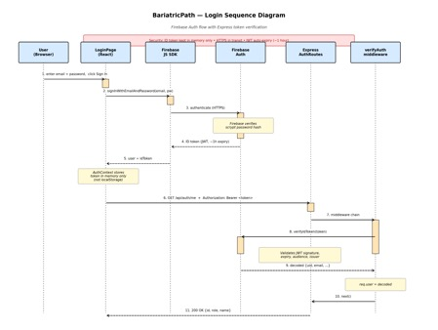
. Login sequence showing the full Firebase authentication flow, the token verification handshake on the backend, and the request-handling chain through verifyAuth middleware. The security callout at the top highlights the three key controls — in-memory token storage, HTTPS in transit, and JWT auto-expiry.

6.4 Authentication Design

Identity provider — Firebase Authentication
Firebase is the identity provider for BariatricPath. It owns:
• Password storage (hashed with scrypt with per-user salts).
• Federated sign-in (Google OAuth).
• Issuance of ID tokens (signed JWTs, RS256, ~1-hour expiry, automatic refresh).
• Account-lockout and per-IP rate limiting on sign-in attempts.

Token verification — firebase-admin
Every protected request carries an Authorization: Bearer <ID token> header. The verifyAuth middleware verifies this token on every request:
const decoded = await admin.auth().verifyIdToken(token);
This call validates the JWT signature against Google's public keys (cached and rotated), checks expiry, audience, and issuer, and returns the decoded claims (uid, email, etc.) on success — or throws on any failure. The middleware then looks up the local User row by firebaseUid and attaches { user } to the request object for downstream handlers.

Why not roll our own JWT and bcrypt?
Design decision: no jsonwebtoken, no bcryptjs
Many tutorials and starter projects use jsonwebtoken + bcryptjs to build authentication. We deliberately chose not to. Firebase already issues JWTs and already hashes passwords (with scrypt, which is stronger than bcrypt). Adding our own JWT system on top would mean two parallel session systems, two attack surfaces, two sets of bugs to find, and two places to invalidate sessions. This is a KISS violation we declined to make. The tutorials suggesting jsonwebtoken+bcrypt assume no Firebase; our architecture is different.

6.5 Authorization Design

Role-Based Access Control (RBAC)
• Every protected API route runs the verifyAuth middleware, which validates the Firebase Bearer token and attaches the resulting user (with role) to the request.
• requireRole(...allowedRoles) is a factory function that returns a middleware checking req.user.role against the allowed roles for that route. Routes compose both: verifyAuth -> requireRole(...) -> handler.
• On the frontend, ProtectedRoute reads the current role from AuthContext and redirects to /login if the user does not have the required role.
• Three portals exist for the Patient, Coordinator, and Director roles, each guarded independently by both server-side RBAC (the layer that actually matters for security) and client-side ProtectedRoute (UX only).

6.6 Audit Logging
Every state-changing operation on a Patient record writes an AuditLog row. The logged fields are: userId (actor), patientId (subject), column (which field changed), oldValue, newValue, and timestamp (server clock). The log is append-only by convention: the application surface exposes only a create operation, never update or delete
In Iteration 1, audit writes are inline in the route handlers. In Iteration 2, this will be refactored into an AuditService module so that the audit-write becomes a single function call, easier to test and easier to keep consistent across routes.

6.7 Input Validation
All HTTP request bodies are validated by express-validator before they reach business logic. Validation rules are declared as middleware arrays attached to each route. Validation failures produce a 400 response with a list of field-level error messages. This protects against:
• Malformed payloads (missing fields, wrong types).
• Injection through unexpected characters in string fields.
• Out-of-range numeric values (BMI, dates).

6.8 Secrets Management
Secret | Where it lives | How it is protected
Firebase service account JSON | Local file referenced by server/.env | Listed in server/.gitignore; never committed; never copied into Docker images.
PostgreSQL password | server/.env (DATABASE_URL) | server/.env in .gitignore; .env.example committed without real values; least-privilege DB user (bariatric_user) created instead of using postgres superuser.
Firebase web SDK config | client/.env | Although the Firebase web config is not strictly secret (it is shipped to the browser), the file is still kept out of git to make leakage of secrets harder in general.
Service account in containers | Mounted into the backend container at runtime | Never copied via Dockerfile COPY; .dockerignore excludes it from the build context.

6.9 Encryption
• In transit: HTTPS in production (planned for Iteration 2/3 deployment). All third-party endpoints (Firebase, Google Sign-In) are already TLS.
• At rest: managed PostgreSQL providers (the planned Digital Ocean deployment) handle disk encryption. We document this as a platform-level control rather than implementing application-level field encryption, since field-level encryption would prevent search and reporting and the project does not require defense against an attacker who has compromised the database host.
• Password hashing: scrypt with per-user salts, handled by Firebase. Not implemented in our codebase by design (Section 6.4).

6.10 Privacy Policy, Disclaimer, Consent
Gap 2 — Privacy Policy, Disclaimer, Consent — SHIPPED (Iter 2)
Status update (Iter 2): All three deliverables are shipped. The implementation followed the original scope from the Iter 1 SDD plan, with no scope reduction.
• Privacy Policy page: available at the /privacy route. Describes the categories of data the application stores (user profile, patient record, audit log, notifications), where it is stored (PostgreSQL + Firebase), and the limited third-party processors involved (Firebase, Google OAuth, OpenAI in the RAG service).
• Medical disclaimer banner: shown on every page accessible to a PATIENT user. States that BariatricPath is an academic project, not a medical device, not a substitute for clinical judgment, and that users must consult a qualified healthcare provider for medical advice.
• Consent checkbox: added to RegisterPage. The Create Account button remains disabled until the user ticks the checkbox confirming they have read the Privacy Policy and the medical disclaimer. The checkbox state is enforced client-side; the server does not currently require it (acceptable for an academic project with synthetic data; would tighten for production).
Owner: Fatimah Hassan (Security Lead). Effort: approximately 5 hours, in line with the 4-6 hour estimate from Iter 1.

6.11 Security Decisions Log
Decision | Date | Rationale | Trade-off accepted
Use Firebase Authentication; do not implement custom JWT or bcrypt | Iter 0 | Firebase already issues JWTs and hashes passwords with scrypt; adding our own duplicates complexity. | Vendor lock-in to Firebase Auth; migration would be moderate effort if needed.
Store ID token in JS memory, not localStorage | Iter 1, Wk 2 | XSS exfiltration risk for tokens in localStorage is real and well-documented. | Token is lost on full page reload; user must sign in again. Acceptable for clinical context.
No passwordHash column on User | Iter 0 | Firebase owns credentials; storing them locally would be duplication and risk. | Cannot migrate users away from Firebase without orchestrating a password reset flow.
AuditLog is append-only by application convention, not by database trigger | Iter 1 | Simpler to reason about; matches the application's actual privilege model. | A direct-DB attacker could in principle modify the log. Acceptable for academic projects; would tighten in production with a DB-level trigger.
RBAC roles defined as a Prisma enum | Iter 0 | Type safety; impossible to assign an invalid role through the application. | Adding a new role requires a migration. Acceptable — roles change rarely.
Author-chosen PR reviewer based on what the change touches | Iter 1, Wk 2 | Security Lead reviews auth/data PRs; Design Lead reviews architecture; QA reviews tests. | Relies on authors picking correctly; mitigated by review checklist.
Object-level ownership check NOT written by Security Lead | Iter 1, Wk 2 | Avoid merge conflicts with engineers' in-flight patient routes; Security Lead reviews instead. | Slightly slower fix; offset by avoiding the chaos of conflicting branches.

Wrap register in a Prisma $transaction (User + Patient + AuditLog atomic) | Iter 1 Wk 3 / Iter 2 | User row, Patient row, and AuditLog row must be created together or not at all. Sequential awaits could leave a User without a Patient or an audit gap. | None — pure improvement. Mock updated to support $transaction callback form.
Close Gap 1 — patient route ownership check (IDOR) | Iter 2 | Without object-level access control, patient #5 could read patient #7's record by URL manipulation. Closed at the route layer comparing req.user.id to the resource's userId. | Coordinator and director roles bypass the ownership check by design (they can see all patients in their scope). Documented and tested explicitly.
Ship Gap 2 — Privacy Policy, Disclaimer, Consent | Iter 2 | Patient data sensitivity demands a clear consent step and an explicit disclaimer even in an academic context. | Consent enforcement is client-side only; server does not re-validate. Acceptable for synthetic-data academic use.
Build AI service as a separate FastAPI microservice (Iter 2 delivered) | Iter 2 | LangChain's Python ecosystem is more mature than JavaScript's. Separate process keeps LLM latency and crash isolation away from the main Express backend. | Extra container to operate; one more network hop. The boundary is sharp (different language, different deployment profile) so the trade-off is favourable.
AI service is internal-only (no host port mapping) | Iter 2 | FastAPI service trusts requests from the Express backend (which has already authenticated the user). Exposing it publicly would require building a parallel auth system inside FastAPI. | All AI traffic must traverse Express. If Express is down, AI is down. Acceptable — Express is the front door for everything.
Pin Prisma to 5.22.0 (CLI + client matched) | Iter 1 Wk 3 | Avoid breaking changes from Prisma 7.x; CLI and runtime client must share the same major version. | Will require a deliberate upgrade later in the year if newer Prisma features become needed.

6.12 Security Posture Summary

Area | Status | Notes
Authentication | Strong | Firebase Auth + server-side token verification on every protected request. Email/password and Google sign-in both supported.
Session management | Good | JWT auto-expiry; in-memory token storage (not localStorage). Server-side revoke on logout deferred to Iter 3.
Role-based access (RBAC) | Done | requireRole middleware + ProtectedRoute on the client. All three roles are enforced at server boundaries.
Object-level access (own records only) | Closed (Iter 2) | Gap 1 closed: patient routes compare req.user.id against resource owner. Verified by TC-IDOR-01.
Input validation | Done | express-validator on all routes. Includes dateOfBirth ISO format on register, BMI range on recommendation endpoint.
Audit logging | Done | AuditLog table; append-only by application convention. Now written atomically via Prisma $transaction with the corresponding state change.
Secrets management | Mostly done | [TEAM TO CONFIRM]: TC-INFRA-05 flagged that .env is visible at /app/.env inside the backend container via the volume mount. For dev environments this is acceptable; for production deployment (Iter 3) the volume mount pattern needs to be reconsidered.
Encryption in transit | Done | HTTPS in production deployment plan. All third-party endpoints (Firebase, Google, OpenAI) are TLS.
Encryption at rest | Platform | Managed Postgres handles disk encryption; documented as a platform control.
Privacy Policy / Disclaimer / Consent | Shipped (Iter 2) | Gap 2 closed: /privacy page, disclaimer banner, consent checkbox on RegisterPage.
STRIDE threat model — login flow | Done (Iter 1) | Section 6.2.
STRIDE threat model — patient routes | [TEAM TO CONFIRM] | Planned Iter 2 deliverable. If not done, defer to Iter 3 with a note in the Decisions Log.

6.13 AI Microservice Security
In Iteration 2 the team shipped a Python FastAPI microservice that handles AI / RAG functionality (the patient-information chatbot). Because this introduces a new component to the system, it deserves its own security analysis.

Design properties
• No public exposure. The FastAPI container is on the shared Docker internal network and is not mapped to a host port. External clients can reach it only by going through the Express backend, which controls authentication and authorization.
• Trust-the-backend identity model. The FastAPI service does not implement its own authentication. It trusts that any caller on the internal network has been authenticated by Express. This is acceptable because nothing else can reach the internal network.
• No database access. The FastAPI service does not have a Postgres connection. It does not receive database credentials. Patient context needed for an AI answer is passed in by Express on a per-request basis — the AI service never queries the DB itself.
• Limited scope. FastAPI does not call Firebase, does not send notifications, does not write audit logs. It is read-only and computes answers from data Express provides.
• Third-party processor: OpenAI. When the RAG pipeline calls OpenAI, the request includes the user's question and a small context window of retrieved documents. No PHI is sent unless the user explicitly references it. The Privacy Policy (Section 6.10) names OpenAI as a third-party processor.

Threats considered
Threat | Mitigation in our design
Direct public access to AI endpoints (bypass auth) | No host port mapping; only Express can reach the container.
LLM prompt injection through user-supplied input | User questions are constrained to the chatbot UI; the system prompt instructs the model to answer only from retrieved context. Out-of-scope user attempts are refused.
Sensitive data leakage to OpenAI | Retrieved context is limited to the requesting patient's own documents and program-wide informational documents. Express enforces this filter before calling FastAPI.
Confidentiality of API keys | OPENAI_API_KEY lives in the ai-service/.env (the AI-service container's env), passed to the FastAPI container as an environment variable. Never committed; never logged.

Business Logic and/or Key Algorithms

7.1 Overview
BariatricPath does not contain heavy algorithmic work, most operations are CRUD-style updates to a patient record. The few non-trivial flows are: (1) user registration with a transactional create across Firebase and PostgreSQL, (2) login token verification, and (3) the audit-log-on-update pattern.

7.2 User Registration — Transactional Create
The registration flow must create two records: a Firebase identity record and a local User row and these two creates must succeed together or fail together. If only the Firebase record is created, we end up with a user who can sign in but has no local profile or role. If only the local record is created, we end up with orphan data.
Algorithm (POST /api/auth/register):
1. Validate the request body with express-validator (email format, password complexity, role is a valid Role enum value).
2. Call firebase-admin.auth().createUser({ email, password, displayName: name }) to create the Firebase record. On failure, return 400 with the Firebase error.
3. In a Prisma transaction, create the User row with the firebaseUid returned by Firebase. On failure, call firebase-admin.auth().deleteUser(firebaseUid) to roll back the Firebase create.
4. Return 201 with the new user's id and role (never the token; the client signs in normally to obtain one).

7.3 Login Token Verification — verifyAuth Middleware
This is the most-executed code path in the system: it runs on every protected request. The algorithm is:
1. Extract the Authorization header. If absent, return 401.
2. Parse out the bearer token. If the format is wrong, return 401.
3. Call admin.auth().verifyIdToken(token). On any error (signature, expiry, audience, issuer), return 401.
4. Look up the local User by decoded.uid (firebaseUid). If not found, return 401 (the Firebase user exists but the local user does not — a state we treat as unauthenticated).
5. Attach { user } to req and call next().
See Section 6.3 (Figure 3) for the sequence diagram of this flow including the full client-side context.

7.4 Audit-Log-on-Update Pattern
Every update to a patient field must write a single AuditLog row capturing what changed. The pattern is:
// pseudocode
async function updatePatientField(req, patientId, column, newValue) {
const before = await prisma.patient.findUnique({ where: { id: patientId } });
const oldValue = before[column];
await prisma.$transaction([ // both in one DB transaction
prisma.patient.update({ where: { id: patientId }, data: { [column]: newValue } }),
prisma.auditLog.create({
data: { patientId, userId: req.user.id, column, oldValue, newValue }
})
]);
}
The transaction is essential: the patient update and the audit log must either both succeed or both fail. Otherwise the audit log can drift from reality.

7.5 Patient Status as a Conceptual State Machine
A patient progresses through a sequence of states in the bariatric evaluation pathway: Referred → InsuranceReview → PreAuthSubmitted → Approved or Denied → (out of scope: Cleared → Scheduled → PostOp). In the current implementation, this state is captured as free-text status fields on patients rather than enforced by code, because clinical workflows often need to capture partial or non-linear states ("insurance approved but cardiology consult missing"). A formal state-machine module is a candidate for Iteration 2 if the team wants stricter enforcement; the trade-off would be reduced flexibility for coordinators.

Design Patterns

Frontend Design Patterns
The React frontend applies the following ten design patterns to keep the codebase organized, reusable, and easy to extend.

1. Context and Provider Pattern
Implemented in: client/src/context/AuthContext.jsx
Global authentication state, including the logged-in user and their role, is stored in a React Context and made available to every component through the useAuth() hook. This removes the need for prop drilling, since any component in the tree can access the current user's information directly.

2. Higher-Order Component (Wrapper) Pattern
Implemented in: client/src/components/ProtectedRoute.jsx
ProtectedRoute wraps page components and adds authentication and role-checking behavior without the wrapped component needing to know it is being protected. The wrapper handles redirecting unauthenticated or unauthorized users before the underlying page is ever rendered.

3. Compound Component Pattern
Implemented in: client/src/components/SearchBar.jsx, PatientTableList.jsx
The coordinator dashboard is built from composed components. SearchBar contains the specialist filter and insurance filter, and PatientTableList renders the resulting patient rows. Each component does one job, and they are assembled together on the page. This favors composition over inheritance.

4. Container and Presentational Pattern
Implemented in: client/src/pages/PatientPortal.jsx, CoordinatorDashboard.jsx, and shared components
Page-level components such as PatientPortal and CoordinatorDashboard handle data fetching and state management, acting as containers. Smaller components such as StatusBadge, ProgressBar, and PatientTableList simply receive props and render UI, acting as presentational components. This separates the data layer from the display layer.

5. Custom Hook Pattern
Implemented in: client/src/context/AuthContext.jsx (useAuth)
useAuth() is a custom hook that encapsulates the logic for accessing the authentication context. Components never interact with the Context API directly - they call useAuth(), which hides the implementation detail of how the auth state is stored and retrieved.

6. Strategy Pattern (Frontend)
Implemented in: client/src/components/StatusBadge.jsx
StatusBadge accepts a type prop, such as specialist, insurance, or checklist, and applies a different label and color mapping strategy depending on which type is passed. The same component renders differently based on the strategy selected at runtime, avoiding the need for separate badge components for each context.

7. Polling Pattern
Implemented in: client/src/pages/PatientPortal.jsx
Notifications are fetched on an interval using setInterval inside a useEffect hook. This is the frontend polling pattern - the application periodically checks for new data from the server without requiring the server to push updates to the client.

8. Optimistic UI and Immutable State Update Pattern
Implemented in: client/src/pages/PatientPortal.jsx
When a notification is marked as read, the UI updates immediately by calling setNotifications(prev => prev.map(...)) without waiting for the server to confirm the change. This keeps the interface responsive while the request completes in the background.

9. Debounce Pattern
Implemented in: client/src/components/SearchBar.jsx
Search input is debounced with a 300 millisecond delay using useRef combined with setTimeout. The search API is not called on every keystroke, only after the user stops typing, which prevents unnecessary network requests.

10. Facade Pattern
Implemented in: client/src/utils/api.js
The apiRequest utility hides the complexity of fetching a Firebase authentication token, attaching it as a header, and handling request errors. Every component calls apiRequest() instead of writing fetch() calls and token logic individually, providing a simple interface over a more complex operation.

Backend Design Patterns
The Express backend and supporting services apply the following design patterns.

1. Singleton Pattern
Implemented in: server/config/prisma.js
The PrismaClient is instantiated once and exported as a single shared instance. Every route file that needs database access imports this same object, which prevents multiple database connections from being opened unnecessarily.

2. Middleware Chain Pattern
Implemented in: server/app.js, server/middleware/verifyAuth.js
Express processes every request through a pipeline of middleware functions, each performing one task and passing control to the next function using next(). The chain includes cors, express.json(), verifyAuth, and requireRole, with the route handler sitting at the end of the chain.

3. Factory Function Pattern
Implemented in: server/middleware/verifyAuth.js
requireRole(...allowedRoles) is a factory function, a function that returns another function. It is called once at route definition time with the roles allowed for that route, and produces a custom middleware configured for that specific check, for example: router.patch('/:id/insurance', verifyAuth, requireRole('COORDINATOR'), handler).

4. Router and Module Pattern
Implemented in: server/app.js and server/routes/
The API is split into separate Express routers for authentication, patients, notifications, and the AI proxy, each mounted at its own path. app.js is the entry point that wires these routers together, and each router owns its own set of concerns.

5. Proxy Pattern
Implemented in: server/routes/ai.js
The Express AI route acts as a proxy between the React frontend and the Python FastAPI AI service. It authenticates the incoming request through Firebase, enriches the payload with data from the database, and then forwards the request to the Python service. The frontend never communicates with the AI service directly.

6. Repository and Service Layer Pattern
Implemented in: server/searchDB/searchDB.js, server/searchDB/calculateProgress.js, server/utils/
Business logic is extracted out of route handlers into separate utility modules, including searchPatients(), computeProgress(), getSpecialistRecommendation(), and createAuditEntry(). Route handlers remain thin and simply coordinate calls to these modules, while the query and calculation logic lives in one place.

7. Strategy Pattern (Backend)
Implemented in: server/searchDB/calculateProgress.js
computeProgress() looks up the required checklist fields for each specialist type from a REQUIRED_ITEMS map and calculates progress accordingly. Each specialist type represents a different strategy for what counts toward completion, and the function selects the correct strategy at runtime based on the patient's visitType.

8. Transaction Pattern
Implemented in: server/routes/auth.js
Patient registration uses prisma.$transaction() to wrap the creation of the User, Patient, and AuditLog records in a single atomic operation. If any step fails, all of the changes are rolled back, which ensures the database is never left in a partial state.

9. Audit Log Pattern
Implemented in: server/utils/auditUtils.js
Every significant data change, including registration, login, and status updates, writes a record to the AuditLog table with the old and new values. This is a standard enterprise pattern used for traceability and compliance.

10. Guard Clause Pattern
Implemented throughout: server/routes/patients.js
Route handlers return early when input is invalid or the request is unauthorized, before the main logic runs. For example: if (!question || !question.trim()) return res.status(400).json(...) and if (existingUser) return res.status(409).json(...). This keeps the primary logic path unindented and easy to read.

11. Catch-All and Fallback Route Pattern
Implemented in: server/app.js
The last middleware registered in the application is a 404 handler that catches any request that did not match a defined route: app.use((req, res) => res.status(404).json({ error: 'Route not found' })). This is the fallback pattern - the unknown case is always handled explicitly.

12. Observer Pattern
Implemented in: client/src/context/AuthContext.jsx
Firebase's onAuthStateChanged callback is an application of the Observer pattern. The application subscribes to authentication state changes and reacts whenever the user logs in or out, without needing to poll for the current authentication status.

13. Retrieval-Augmented Generation Pattern
Implemented in: ai-service/rag.py
The AI service uses retrieval-augmented generation. Rather than relying solely on the language model's training data, it first retrieves relevant documents from ChromaDB and passes them as context to the language model before generating a response. This is an AI-specific architectural pattern that improves the accuracy and relevance of generated answers.

1. Client-Server Architecture
The system is built on a decoupled architecture separating the presentation layer from the data and business logic layers.
- Client: A React Single Page Application (SPA) responsible for UI and user interaction.
- Server: A Node.js/Express RESTful API responsible for secure data transactions, email processing, and database communication.
2. Model-View-Controller Paradigm
While modern JavaScript frameworks blur strict MVC lines, the project heavily borrows from it:
- Model (Data Layer): Managed entirely by the Prisma ORM (schema.prisma). It defines relationships between User, Patient, AuditLog, and Notification entities.
- View (Presentation Layer): React components (client/src/pages/*) render the state of the data to the user.
- Controller (Logic Layer): Express route handlers (server/routes/*) receive client requests, orchestrate updates via Prisma, and return HTTP responses.
3. Provider / Context Pattern
Location: client/src/context/AuthContext.jsx Instead of passing authentication state and user roles down through dozens of nested components ("prop drilling"), the application uses React's Context API. The AuthProvider wraps the application, broadcasting the current Firebase User and their role globally to any component that subscribes to it.
4. Singleton Pattern
Location: server/routes/patients.js & client/src/config/firebase.js The application strictly manages heavy resources to avoid memory leaks:
- PrismaClient: Instantiated once and reused to maintain a single efficient database connection pool.
- Nodemailer: The email transporter is instantiated globally at the top of the route file rather than inside the POST request, ensuring only one active SMTP connection manager exists.
5. Decorator / Proxy Pattern
Location: client/src/components/ProtectedRoute.jsx The ProtectedRoute component acts as a Proxy or Decorator around standard React Router components. Before a user can view sensitive pages (like the Patient Portal or Dashboard), this component intercepts the render cycle, verifies the user's authentication token, validates their Role Array (e.g., ['PATIENT']), and redirects them to /login if they are unauthorized.
6. Facade Pattern
Location: client/src/utils/api.js The apiRequest utility function acts as a Facade over the native JavaScript fetch API. It hides the immense complexity of:
- Reaching into the Firebase instance to dynamically fetch fresh Auth Tokens.
- Injecting Authorization: Bearer headers.
- Automatically injecting the dynamic VITE_API_URL environment variables.
- Standardizing error handling. This allows the rest of the application to simply call apiRequest('/patients/123') without knowing how the underlying authentication works.
7. Strategy / Encapsulation Pattern
Location: server/utils/routingLogic.js Rather than hardcoding the complex BMI logic directly inside the Express route handler, the logic for determining a patient's specialist path is extracted into an independent getSpecialistRecommendation function. This encapsulates the business rules, making the logic easily unit-testable (as seen in routingLogic.test.js) and allows the backend routing strategy to change without affecting the API layer.

8. Single Responsibility Principle (SRP)
Concept: A component should have only one reason to change.
Application: Decomposed the monolithic PatientPortal.jsx (which was rendering checklists, progress bar, coordinator help, and notifications) into distinct, modular child components, reducing the main page file by 65%.
9. DRY (Don't Repeat Yourself) / Reusability
- Concept: Consolidating duplicate code into a single source of truth.
- Application: Avoided creating a duplicate progress bar by refactoring the existing ProgressBar.jsx (from the coordinator view) to accept configuration props (alwaysGreen, striped, animated, variant="detailed") to support multiple dashboard styles.
10. Component Encapsulation
- Concept: Hiding implementation details and internal state from parent views.
- Application: Moved checklist row subtext logic and SVG status icons inside PatientChecklist.jsx. The main page only acts as an orchestrator, keeping the high-level codebase clean.
11. Self-Healing Database Pattern (Defensive Programming)
- Concept: System automatically detects and repairs incomplete or corrupted states.
- Application: Added a self-healing block to the backend /login route. If a patient logs in but is missing their linked Patient record (e.g. from an incomplete Google login), the system auto-generates the missing record instantly.

Rest APIs

1.BariatricPath Backend API
This is a custom REST API built with Node.js and Express, running on port 5001. It follows REST conventions. Each URL represents a resource, and HTTP methods (GET, POST, PATCH) indicate the action. All endpoints are prefixed with /api.

Authentication Routes /api/auth

Authentication Routes /api/auth
Method | Endpoint | Status | Description
POST | /api/auth/register | Implemented | Creates a new patient account. Accepts name and Firebase idToken. Verifies the token, then creates a User record with the role PATIENT
POST | /api/auth/login | Implemented | Verifies Firebase idToken, looks up the user in the database, returns id, name, email, and role. Fronted uses the role to redirect to the correct portal.
GET | /api/auth/me | Implemented | Returns the currently logged in user’s details. Protected by verifyAuth. Requires a valid Firebase token in the Authorization header.

Patient Routes /api/patients

Patient Routes /api/patients
Method | Endpoint | Status | Description
GET | /api/patients | Implemented | Returns all patients. Supports ?search=(name, MRN, date of birth), ?specialistType=,?insuranceStatus=. Each patient includes a computed progress field.
GET | /api/patients/:id | Implemented | Returns a single patient by database ID. Returns 404 if not found
POST | /api/patients/recommendation | Implemented | Calculates specialist recommendation from bmi and previousSurgery. Logic: below 27→Not eligible, 27-29.9→ Obesity Medicine Specialist, 30-34.9→Endoscopic Obesity Specialist, 35+ or previous surgery → Bariatric Surgeon.
POST | /api/patients/:id/submit | Implemented | Submits the patient’s completed profile. Does three things: fetches the patient record, creates a coordinator Notification in the database, and sends a confirmation email to the patient using Nodemailer.
PATCH | /api/patients/:id/specialist | Implemented | Saves the patient's confirmed specialist choice to the visitType field in the database,
POST | /api/patients | Implemented | List all patients (search + filter supported) d
PATCH | /api/patients/:id/insurance | Implemented | Coordinator updates insurance status
PATCH | /api/patients/:id/clinical | Implemented | Coordinator updates clinical field

Notification Routes /api/notifications
Two of the three routes are implemented.

Notification Routes /api/notifications
Method | Endpoint | Status | Description
GET | /api/notifications/:patientId | Stub | Placeholder to retrieve all notifications for a patient
PATCH | /api/notifications/:id/read | Implemented | Mark notification as read
POST | /api/notification | Implemented | Create a new notification

Additional Routes

Method | Endpoint | Status | Description
POST | /api/ai/chat | Implemented | Send question to AI
GET | /api/health | no | Health check

Firebase Authentication API (External - Google)
- Frontend : Firebase JavaScript SDK handles user registration and login with email and password. Returns a JWT ID token after successful authentication
- Backend: Firebase Admin SDK verifyAuth middleware verifies the ID token on every protected request.

Supabase/ PostgresSQL via Prisma (External Database)
Hosted PostgreSQL database accessed through Prisma ORM. Stores four
Tables: User, Patient, AuditLog, and Notification.

Nodemailer / Gmail SMTP(External Email)
Used in POST /api/patients/:id/submit. Sends a confirmation email to the patient after they
Complete their registration, informing them of their recommended specialist and that a
coordinator will contact them within 1-2 business days. Requires EMAIL_USER and
EMAIL_PASS environment variables.

OpenAI API (External Planned, Not Yet Implemented)
The openai package is installed and OPENAI_API_KEY is in the .env. Planned for a future sprint., for the AI recommendation or patient communication in the ai-service/ folder

Deployment
BariatricPath is deployed on a single DigitalOcean droplet running Ubuntu. All five services the React frontend, Express backend, FastAPI AI service, PostgreSQL database, and Nginx reverse proxy run as Docker containers orchestrated by Docker Compose. Nginx sits at the top and handles all incoming HTTPS traffic on port 443, routing API requests to the backend and everything else to the frontend. The AI service and the database are only reachable from inside the Docker network — they have no public ports exposed.

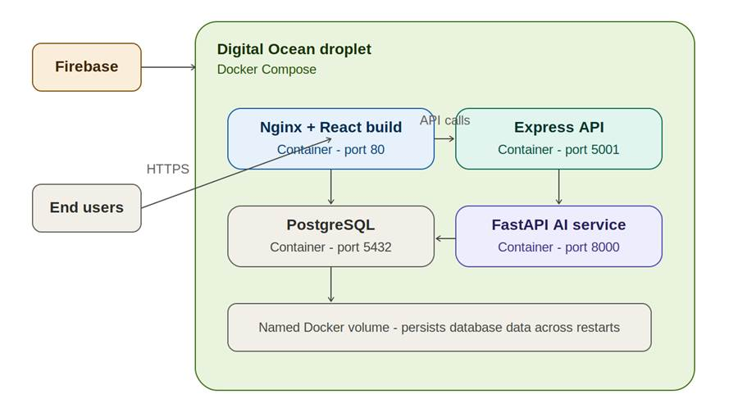
Figure 16. Deployment on a Digital Ocean droplet
For secrets, nothing is committed to the repository. All Firebase credentials, database URLs, and API keys are injected through environment variables on the droplet.

For email, we use Nodemailer with Gmail to send confirmation emails when a patient submits their profile. This works in local development, but DigitalOcean blocks outbound SMTP on new droplets, so emails are skipped silently on the live server. The submission still completes normally.

For CI/CD GitHub Actions runs all our test and security workflows on every push and every PR. But deployment is manual. When we are ready to release, we SSH into the droplet, pull from main, and run docker compose up. That manual step was intentional we wanted a human to sign off before anything reached the live environment."

AI usage Log

Section | Who | AI contribution (%) | Description | Verified by
1 | Kai | 60% | AI summarized the document, I verified that the summary was correct and provided the Design Goals section | Kai
Section 2.1, 2.2, 2.3, 2.4, 2.5, 2.6  (Architecture) updates | Fatimah | [HYBRID] ~30% | AI drafted from project context; architecture diagram generated programmatically. Section owner to validate component descriptions  AI microservice promotion from "planned" to "shipped" wording, frameworks table row update. [HYBRID] ~30%. | Fatimah
Section 3 | Kai | [HYBRID] ~40% | Section owner drafted initial classes and packages based on github code structure, AI drafted descriptions and class connections based on provided context and section owner verified | Kai
Section 4.1, 4.2, 4.3, 4.4, 4.5 | Fatimah | [HYBRID] OVER 40% | First-pass description of pages and UX flow. | Fatimah
Section 4.6, 4.7 | Kolya | [HYBRID] 50% | I drafted the original description and revised it with AI for mistakes or details I forgot to mention. | Kolya
Section 5 | Kolya | [HYBRID] 30% | I drafted the original description and revised it with AI for mistakes or things I forgot to mention. I added the schema as context, and used it to create the UML diagram as well. | Kolya
Section 6(Security Design): | Fatimah | [HYBRID] OVER 50% | Iter 2 updates owned end-to-end by the Security Lead. New 6.13 (AI Microservice Security), Gap 1 closure verification, Gap 2 implementation, expanded Decisions Log, refreshed Posture Summary.AI assist for structure; security content, gap verifications, and decisions log written and reviewed by Fatimah. | Fatimah
Section 7.1, 7.2, 7.3, 7.4, 7.5, References, Glossary | Fatimah | [HYBRID] OVER 20% | Pseudocode reflects real implementation patterns. | Fatimah
Section 8 | Jianing | 40% | Drafted original version and enhanced by Google Antigravity after browsing through the entire code base. AI identified and recommend several additional design patterns as well. | Kolya
Section 9 | Shaima | 40%  0% | Used Claude to help identify REST API endpoints needed for the BariatricPathway application based on the user stories BARI-7 through BARI-16 and describe their purpose request format and response format Final API design was reviewed and modified to match the actual project schema and team implementation decisions  - Iteration 2 updated the status of REST APIs implemented in iteration 2 and added 2 extra APIs | Kolya

References
• Firebase Authentication documentation. https://firebase.google.com/docs/auth
• firebase-admin Node.js SDK. https://firebase.google.com/docs/admin/setup
• Prisma ORM documentation. https://www.prisma.io/docs
• Express.js documentation. https://expressjs.com
• React documentation. https://react.dev
• Bootstrap 5 documentation. https://getbootstrap.com
• OWASP Top 10 — 2021. https://owasp.org/Top10/
• OWASP Insecure Direct Object Reference (IDORhttps://owasp.org/www-community/Insecure_Direct_Object_Reference
• STRIDE threat model — Microsoft Security Development Lifecycle. https://learn.microsoft.com/en-us/azure/security/develop/threat-modeling-tool-threats
• Conventional Commits 1.0.0. https://www.conventionalcommits.org
• Jacobson, I., Christerson, M., Jonsson, P., Övergaard, G. Object-Oriented Software Engineering: A Use Case Driven Approach. Addison-Wesley, 1992. (Origin of the Entity / Control / Boundary pattern.)
• Fowler, M. Patterns of Enterprise Application Architecture. Addison-Wesley, 2002. (Repository, layered architecture, Service Layer.)
• CS673 Project Description and SPPP template, Boston University Metropolitan College, Summer 2026.

Glossary

Term | Definition
BMI | Body Mass Index — clinical metric used as part of bariatric surgery eligibility.
CI/CD | Continuous Integration / Continuous Delivery (or Deployment) — automated build, test, and deploy on every change.
DAST | Dynamic Application Security Testing — security testing on a running application (e.g., OWASP ZAP).
ECB | Entity / Control / Boundary — analysis-time classification of classes from the Unified Process.
IAAA | Identification, Authentication, Authorization, Accountability — the four pillars of access management.
IDOR | Insecure Direct Object Reference — a vulnerability where an attacker can access a resource by manipulating its identifier, because no ownership check is enforced.
JWT | JSON Web Token — a signed, base64-encoded token format. Firebase ID tokens are JWTs.
KISS | Keep It Simple, Stupid — design principle favoring the simplest design that meets requirements.
MRN | Medical Record Number — the patient identifier inside a healthcare program.
MVC | Model–View–Controller — architectural pattern separating data, presentation, and control logic.
PHI | Protected Health Information — patient data subject to healthcare regulation in many jurisdictions.
RBAC | Role-Based Access Control — authorization based on the role assigned to the user.
RAG | Retrieval-Augmented Generation — pattern where retrieved documents ground a language model's answer.
SAST | Static Application Security Testing — analyzing source code for security issues without running it.
SDD | Software Design Document — this document.
scrypt | A password-based key-derivation function designed to be costly in memory; used by Firebase to hash passwords.
SPPP | Software Project Proposal and Planning — the planning document submitted earlier in the course.
SPA | Single-Page Application — a web app that loads once and updates content via JavaScript without full-page reloads.
STRIDE | Spoofing, Tampering, Repudiation, Information disclosure, Denial of service, Elevation of privilege — a threat-modeling framework.
TLS | Transport Layer Security — the protocol underlying HTTPS.

